

AWS INTERNSHIP PROJECT

An Architectonics Of AWS With 2 VPC’s, 2 Subnets In 2 Different Regions on Disaster Resilience -7 Tier Architecture.

DRIVEN FORWARD BY:

**MR. AASHU DEV**

B. Tech, AWS Solution Architect (2x) Certified, AWS Academy Accredited Educator

PUTTAPUDI SUJATHA: 21B91A04J6 KARI JYOTHI CHANDRIKA: 21B91A5722

KATTAMURI NAGA HANUMANTHA RAO: 21B91A5723

0



Our Foresee alias 4c describes the

meaning “predict or on beforehand” in one way and on the other hand it

acronyms creative cloud connectivity corporation .

1



An Architectonics Of AWS With 2 VPC’s, 2 Subnets In 2

Different Regions on Disaster Resilience -7 Tier Architecture.

This architecture is to transfer the data from an instance of one VPC with its corresponding

subnet to other instance of another VPC with its corresponding subnet via snapshot and its copy with extra volume. Also, the AMI (Amazon Machine Images) in this helps you to create the virtual servers known as EC2 instances in the Amazon Web Services (AWS)

environment. The cloud 9 associated with the first VPC helps you to store the files locally on the instance or servers. The IAM (Identity and Access Management) in our architecture is

an identity that we can create in our account that has specific permissions. EFS in this

architecture i.e. Elastic File Systems helps to create, mount the file system on an Amazon EC2 instance. The last tier -S3, Simple Storage Service is cloud object storage with industry- leading scalability, data availability, security and performance.

2

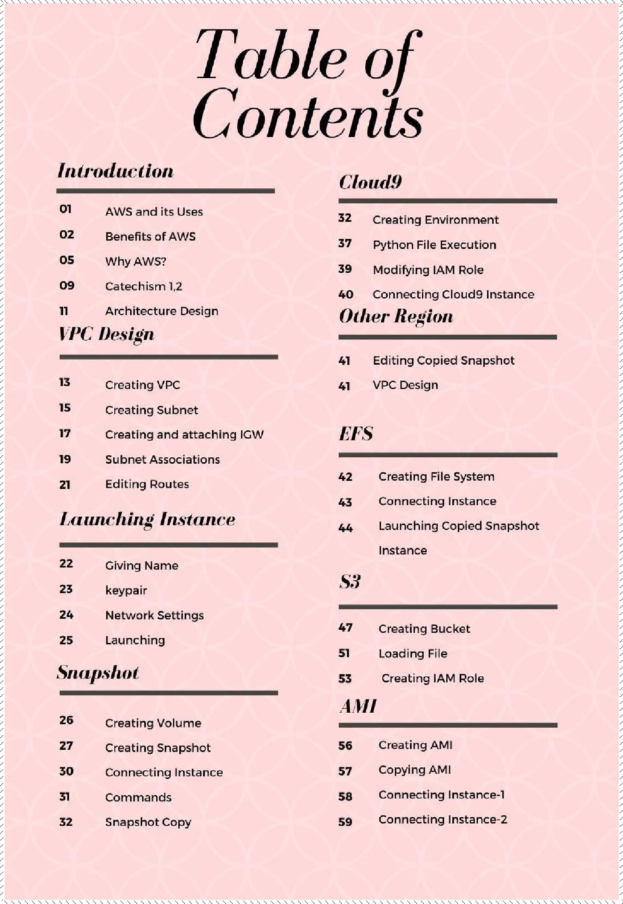

3

What is AWS?

* AWS stands for **Amazon Web Services**.
* The AWS service is provided by the Amazon that uses distributed IT infrastructure to provide different IT resources available on demand. It provides different services such as infrastructure as a service (IaaS), platform as a service (PaaS) and packaged software as a service (SaaS).
* Amazon launched AWS, a cloud computing platform to allow the different organizations to take advantage of reliable IT infrastructure.

Uses of AWS

* A small manufacturing organization uses their expertise to expand their business by leaving their IT management to the AWS.
* A large enterprise spread across the globe can utilize the AWS to deliver the training to the distributed workforce.
* An architecture consulting company can use AWS to get the high-compute rendering of construction prototype.
* A media company can use the AWS to provide different types of content such as e-box or audio files to the worldwide files.

Pay-As-You-Go

Based on the concept of Pay-As-You-Go, AWS provides the services to the customers. AWS provides services to customers when required without any prior commitment or upfront investment. Pay-As-You-Go enables the customers to procure services from AWS.

* Computing
* Programming models
* Database storage
* Networking

1

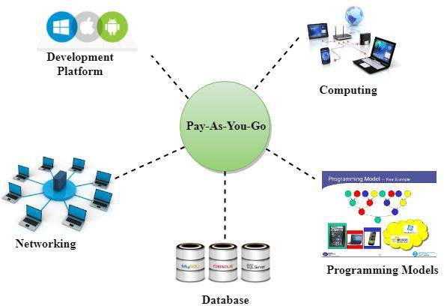

**Benefits of AWS:**

### Cost-Effective:

This reduces your operating costs because you only need to pay for compute power, storage, and other resources you use. And there are no long-term contract commitments required.

### Easy to use:

The AWS interface does not cause any kind of problems, even newbies can easily use the AWS management console.

### Flexibility:

On AWS, you get a virtual environment that gives you the freedom to load the software and services that your application needs.

### Scalable:

2

Using AWS tools, such as auto-scaling, and elastic load balancing, your application can scale up or down depending on demand. You have the freedom to access additional compute and storage resources when needed.



### Adaptable:

AWS is designed to quickly and securely host your application on a cloud platform. AWS allows you to select the operating system, web application, programming language, database, and other services you need.

### Automation:

Amazon Web Services uses an automation system and performs many tasks automatically when needed. In this way, it reduces the workload of the user. With AWS’s sophisticated automation, they can predict and prevent failures before they occur.

### Content Delivery:

CloudFront is a fast content delivery network (CDN) service owned by AWS. It safely delivers data, video, and applications to customers globally with low latency and high transfer speeds.

Meanwhile, CDN reduces the load on the application root and improves the overall user experience.

### High-Performance:

AWS is designed to handle high traffic and automatically increases its resources as needed. As a result, you get higher performance.

### Easy Cloud Migration:

The main benefits of migrating to AWS enable the migration process for existing applications while preserving options for creating new applications.

### Advanced Security:

AWS uses advanced technology to secure its cloud infrastructure, which includes physical, operational, and software measures. AWS cloud security has many advantages.

### Backup and Restore:

AWS Cloud provides superior scalability, and its cloud-enabled backup solutions are carefully designed for backup and restore

Data.

3

Traditional methods such as tape libraries and secondary sites lose their importance as many organizations are now increasing backup targets on the cloud.

### Higher Availability:

High availability solutions provide data protection for businesses that want to move to Amazon Web Services (AWS), as well as the reliable performance with minimal downtime and cost.

### Reliable Infrastructure:

Reliability incorporates the ability of a workload to perform its intended work correctly and consistently when it is expected. With AWS, most reliability fundamental requirements are already included or can be addressed as needed.

### Comprehensive Update:

AWS Systems Manager Patch Manager controls and automates the process of installing security-related updates for both operating systems and applications. However, you can follow any recommended procedures or automated update services to install updates provided by the application vendor.

### Skilled IT Support Staff:

AWS Customer Service provides global support to its millions of customers globally. They provide immediate guidance to satisfy customers on the cloud journey and answer questions to fix the problem.

### Use of Innovative Technology:

The rapid pace of technological change needs to be revised and updated accordingly. Therefore, AWS implements various new technologies and applies them to its cloud platform.

### Improve Overall Productivity:

It has millions of customers, including the largest enterprises, the fastest- growing startups, and many government agencies using AWS for lower costs, more secure, and faster speeds.

### Increase Customer Satisfaction:

Customer satisfaction is the primary objective of AWS and its IT support staff works 24 hours to achieve this goal.

4

### Largest Global Cloud Infrastructure:



AWS is the world’s most comprehensive and widely adopted cloud program,

providing more than 200 fully featured services from data centres globally.

### Global Leader of Cloud Computing:

It owns and controls about half of the world’s public cloud infrastructure

market, so [Amazon Web Services](https://aws.amazon.com/) (**AWS**) is the clear market leader.

### Low-Cost Website and Web Application Hosting:

You can host your website with reliable and scalable hosting services from Amazon Web Services. Its cloud platform is a secure, scalable, sustainable, worldwide data centre, and features a flexible value model.

1. **R E L I A B I L I T Y**

AWS is considered to be one of the most reliable cloud services, trumping peers such as Google and Microsoft. Even if you’ve heard of some high-profile outages through the media, Amazon Web Services outages are rare. In fact, the reason these issues were high-profile is that so many popular services use AWS due to its reliability.

# F L E X I B L E P R I C I N G : C H O O S E A W S

AWS offers a wide array of services and its prices vary according to which of those services you require and for what time period you’ll need them. Their services include a pay-as-you-go option that can help you save costs and easily scale up as your business grows. No long-term contracts or commitments are required, which is quite a change from what had been available in the past.

# F R E E T I E R

In addition to flexible pricing, AWS includes a free tier that offers over 85 products for 12 months, as well as some short-term free trials for some of its products. These, of course, come with specified limits, but allow you to sample the products and find the best fit before making a financial commitment. Some of the services offered for free include Amazon S3, [AWS Lambda](https://aws.amazon.com/lambda/?did=ft_card&trk=ft_card) and [Amazon Guard Duty](https://aws.amazon.com/guardduty/?did=ft_card&trk=ft_card).

# S E C U R I T Y : C H O O S E A W S

5



Amazon Web Services offers world-class security that meets the highest standards. It includes many compliance programs within its infrastructure as well as a comprehensive security support network. Its security features include a free [Identity](https://aws.amazon.com/iam/?nc2=type_a) [and Access Management](https://aws.amazon.com/iam/?nc2=type_a) (IAM) service to secure your AWS resources and make sure only lawful users can gain access.

# S C A L A B I L I T Y A N D F L E X I B I L I T Y : W H Y W E C H O O S E A W S

As we’ve mentioned, AWS offers a variety of services and a global infrastructure. Moreover, as the company has a massive cloud-based platform, businesses have access to servers and storage on demand without the restrictions of physical computing infrastructure. All of this allows you to easily scale and adapt your mobile or web app project according to your needs. There is also no limitation when it comes to operating systems or development environments, making it an extremely flexible tool.

# D E V E L O P M E N T T O O L S

Amazon Web Services includes its very own development tools: [AWS CodeDeploy](https://aws.amazon.com/codedeploy/?nc1=h_ls)— which deploys code to EC2 servers—, [AWS Code Commit](https://aws.amazon.com/codecommit/)—a source control service

6

that conveniently hosts Git repositories—, and [AWS Code Pipeline](https://aws.amazon.com/codepipeline/)—a service that helps you automate the software release process.

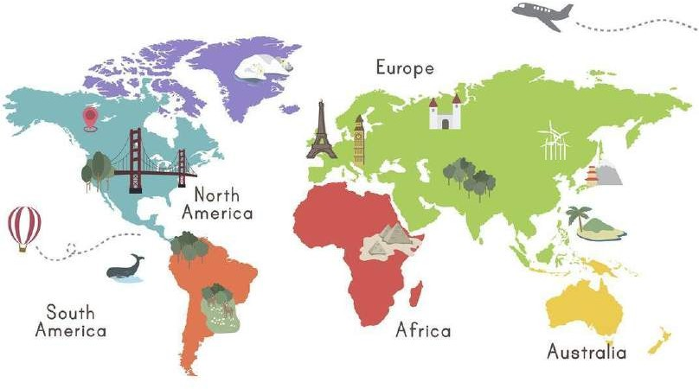

# L O C A T I O N A N D G L O B A L P R E S E N C E

AWS has locations in 25 regions around the globe and a presence in 80 global availability zones, with constant plans for expansion. They have plans to add 5 extra regions and 15 extra availability zones. This means Amazon Web Services is available no matter where in the world you or your customers are.

# E C O S Y S T E M

ASW’s ecosystem is vast, with over 165 featured services including anything from encryption and databases, to networking and analytics. This means Amazon Web Services will very likely be able to meet any mobile or web app development needs you may have.

# S U P P O R T A N D R E S O U R C E S

Because of its status as a global leader, Amazon Web Services has outstanding support 24/7. Not to mention, there is extensive documentation and countless resources available if you need them. You can check out [AWS’s support overview](https://aws.amazon.com/premiumsupport/?nc2=h_m_bc), its [knowledge center](https://aws.amazon.com/premiumsupport/knowledge-center/?nc2=h_m_ma) and its [client support center](https://console.aws.amazon.com/support/home/?nc2=h_ql_cu) for help. Amazon Web Services also offers [training and certification](https://aws.amazon.com/training/?nc1=f_cc) to support you along your journey.

7



8

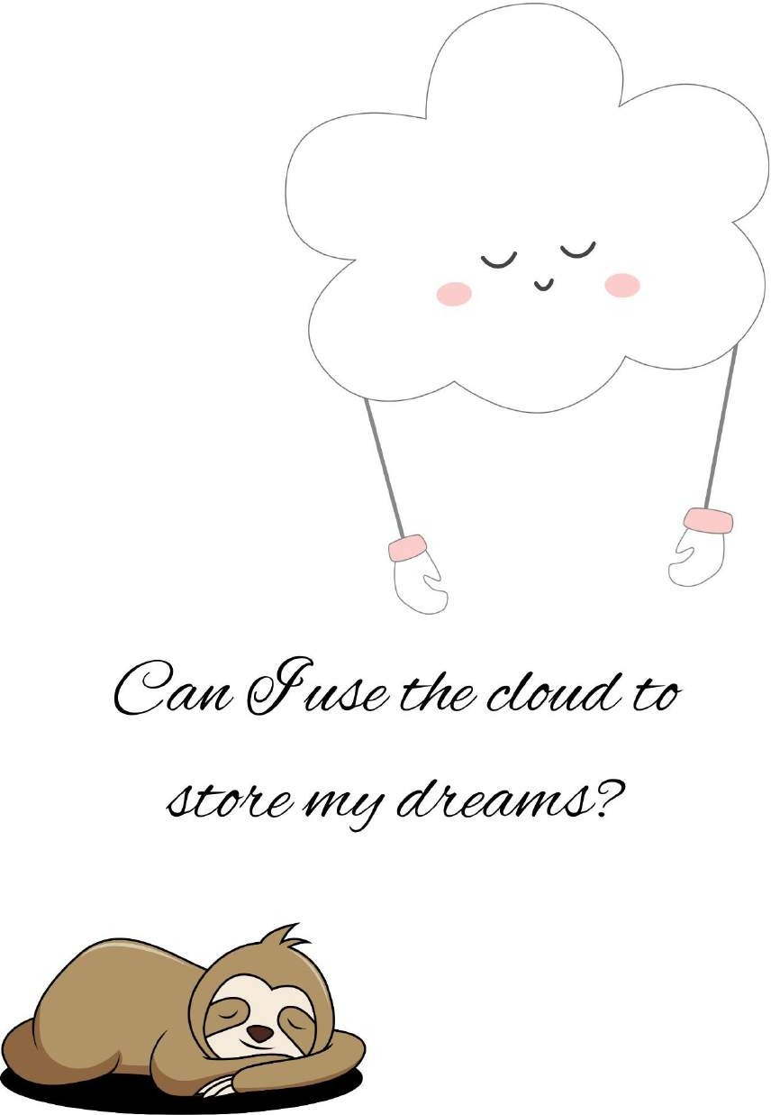

9

BACK TO “ARCHY THING”

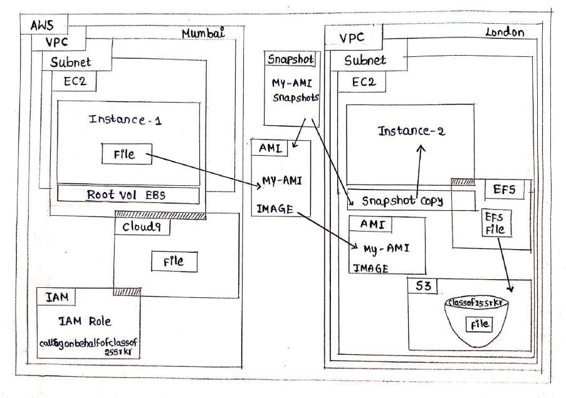

- A glance of rough architecture:

PEEK A FAIR ONE NOW:

10

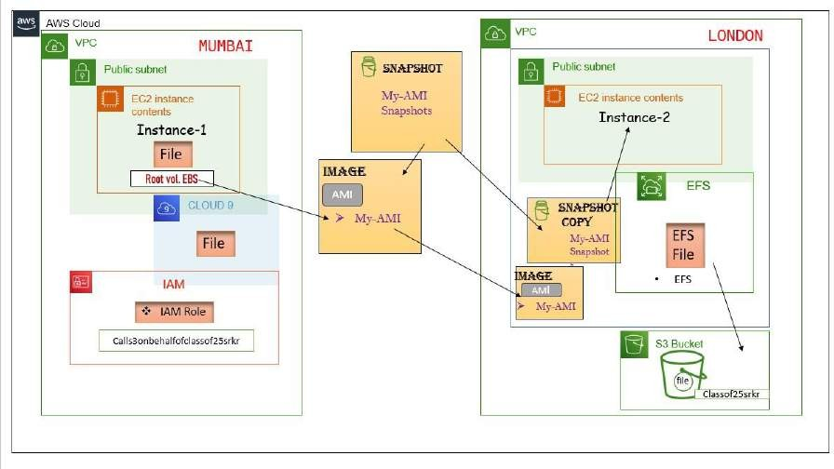

AWS Icons:

## VPC (Virtual Private Cloud):

Amazon Virtual Private Cloud (VPC) is a fundamental networking service in AWS. It

enables users to create a private, isolated network within the AWS cloud. VPC allows full control over IP address ranges, subnets, route tables, and network gateways.

Users can launch and manage AWS resources, such as EC2 instances and RDS databases, inside the VPC securely. VPC provides options for both IPv4 and IPv6 address assignment. A VPC can be connected to an organization's on-premises data centre using Virtual Private Network (VPN) or AWS Direct Connect for hybrid cloud scenarios. Network Access Control Lists (NACLs) and Security Groups (SGs) are used

to control inbound and outbound traffic at the subnet and instance level. VPC Peering allows private communication between VPCs in the same region. AWS Private Link

enables access to AWS services over private connections, enhancing security.

## Subnet:

In AWS, a subnet is a division of an Amazon Virtual Private Cloud (VPC) IP address range. It acts as a segmented network within the VPC, allowing users to deploy and

11

manage resources in isolated environments. Each subnet is associated with a specific Availability Zone (AZ) within an AWS region. Users can create multiple subnets in a VPC to distribute resources for high availability and fault tolerance. Subnets define



the IP address range for EC2 instances and other AWS services deployed within them. They also serve as a boundary for network access control using Network Access

Control Lists (NACLs) and Security Groups (SGs). Subnets enable private

communication between instances within the same VPC and can be interconnected through VPC Peering for communication between VPCs.

EC2:

Amazon Elastic Compute Cloud (EC2) is a core service in AWS, offering resizable compute capacity in the cloud. EC2 allows users to launch and manage virtual servers, known as instances, based on their specific needs. Users can choose from

various instance types, each tailored for specific use cases, such as general-purpose, memory-optimized, or GPU-accelerated.

EC2 instances are billed on a pay-as-you-go basis, with the ability to start, stop, and terminate instances as required. Users can also create custom Amazon Machine

Images (AMIs) to replicate configurations across instances.

With EC2, users have full control over their virtual machines, including OS,

networking, security, and storage options. EC2 instances can be easily scaled up or down to accommodate fluctuating workloads and are often used to run applications, host websites, process data, and perform various computing tasks in a flexible and cost-effective manner.

12

## Cloud9:

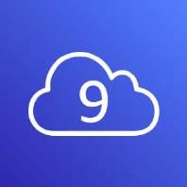

AWS Cloud9 is an integrated cloud-based Integrated Development Environment (IDE) that allows developers to write, run, and debug code from a web browser. It provides a collaborative environment, enabling multiple developers to work together on the same code in real-time. Cloud9 supports a wide range of programming languages and comes pre-configured with essential development tools.

With Cloud9, developers can seamlessly access their projects and code from

anywhere, as the environment is hosted in the AWS cloud. It offers features like code highlighting, auto-completion, and code navigation to enhance productivity. Cloud9 also integrates with other AWS services, facilitating easy deployment and testing of applications.

By utilizing Cloud9, developers can eliminate the need for local development

environments and enjoy the benefits of a scalable, fully-managed cloud-based IDE, promoting efficient coding practices and collaboration within development teams.

## IAM (Identity and Access Management):

AWS Identity and Access Management (IAM) is a web service that allows users to securely control access to AWS resources. IAM enables the creation and management of users, groups, and roles, defining permissions for each entity using policies. It follows the principle of least privilege, granting only the necessary permissions to

perform specific actions on AWS services.

IAM provides centralized authentication and authorization, ensuring secure access to AWS resources. Users can securely sign in to the AWS Management Console, CLI, or SDKs using IAM credentials. It supports Multi-Factor Authentication (MFA) for additional security.

13

IAM also integrates with other AWS services, allowing users to grant permissions to services and resources on a fine-grained level. By implementing IAM, organizations can enforce strong security practices, manage access control efficiently, and audit user activity across their AWS infrastructure.



## Snapshot:

In AWS, a snapshot is a point-in-time backup of an Elastic Block Store (EBS) volume. It captures the data and configuration of the volume, allowing for easy data recovery and duplication. Snapshots are stored in Amazon Simple Storage Service (S3) and are incremental, capturing only changed blocks since the last snapshot, minimizing storage costs.

Snapshot Copy is a feature that enables copying of EBS snapshots across AWS Regions. This facilitates disaster recovery, data replication, and compliance

requirements. By copying snapshots to a different region, users can enhance data resilience and reduce the risk of data loss in case of a region-wide outage.

Both snapshots and snapshot copies are essential tools for data protection and disaster recovery in AWS, providing flexible, scalable, and cost-effective solutions for safeguarding critical data in the cloud.

## AMI (Amazon Machine Image):

In AWS, an Amazon Machine Image (AMI) is a pre-configured template used to

launch virtual servers (EC2 instances). It contains an operating system, applications, and configurations required to start an instance. AMIs can be created from existing instances or shared by other users.

AMIs are available in public repositories or private ones, allowing users to access a variety of OS and software configurations. They are instrumental in achieving

14

consistency and scalability across instances, as multiple instances can be launched from the same AMI.

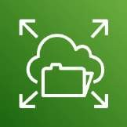

AMI backups, known as snapshots, are stored in Amazon S3, allowing easy replication and restoration of instances. By utilizing AMIs, users can rapidly deploy and scale applications, reducing setup time and ensuring consistency in their AWS

infrastructure.

## EFS (Elastic File System):

Amazon Elastic File System (EFS) is a scalable, fully-managed file storage service in AWS. It provides shared file storage for multiple EC2 instances, supporting concurrent access from multiple users. EFS is designed to be highly available and durable.

EFS is designed to scale automatically, growing and shrinking as data storage needs

change, without any capacity planning required. It supports the Network File System (NFS) protocol, making it compatible with Linux-based applications.

With EFS, users can store and share data across multiple instances within a VPC, eliminating the need for managing file servers. It also supports data backup and restoration using Amazon EFS Backup service.

EFS is suitable for applications that require shared access to files across multiple

instances, offering a cost-effective and efficient solution for managing file storage in the cloud.

## S3 (Simple Storage Service):

Amazon Simple Storage Service (S3) is a highly durable and scalable object storage service in AWS. It allows users to store and retrieve any amount of data from

anywhere on the web. S3 provides industry-leading availability, durability, and security for data storage.

Data in S3 is organized into "buckets," which are unique containers for objects (files). Each object can be up to 5 TB in size. S3 supports various storage classes, including Standard, Intelligent-Tiering, Glacier, and others, to optimize data access and cost.

15

S3 is widely used for backup and restore, content distribution, big data analytics, and serving static assets for websites and applications. With its simple API, data



consistency, and integration with other AWS services, S3 is a fundamental building block for various cloud-based storage solutions.

HAVE A LOOK OF THE PROCESSING OF THE CONSTRUCTION….

let ’s go through it…….

16

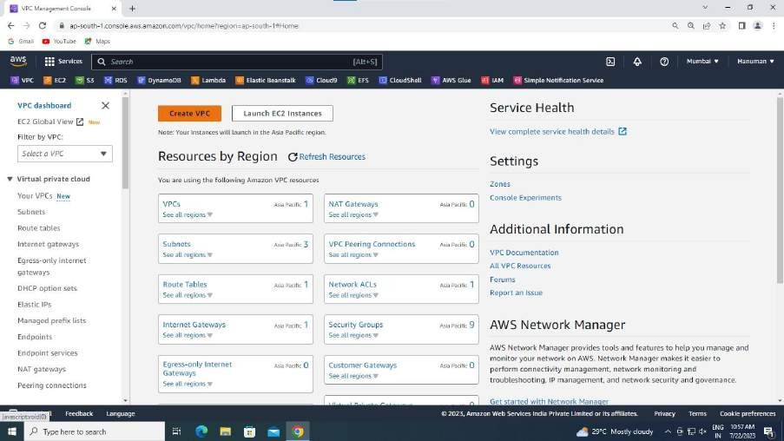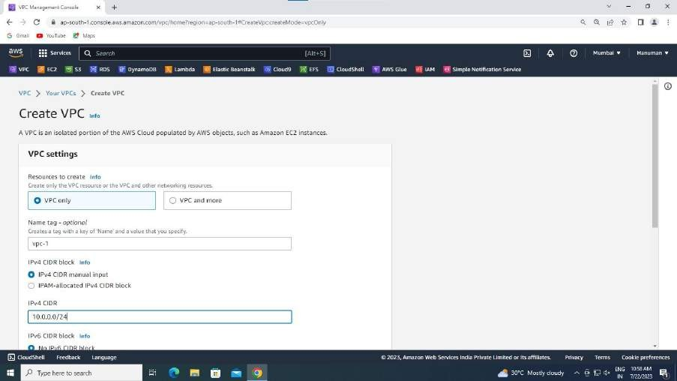

* In the AWS account go to VPC tab.
* Then click on create VPC. (Shown above, highlighted in orange colour).
* Then the one shown below appears.
* Give the IP address as: 10.0.0.0/24.

17

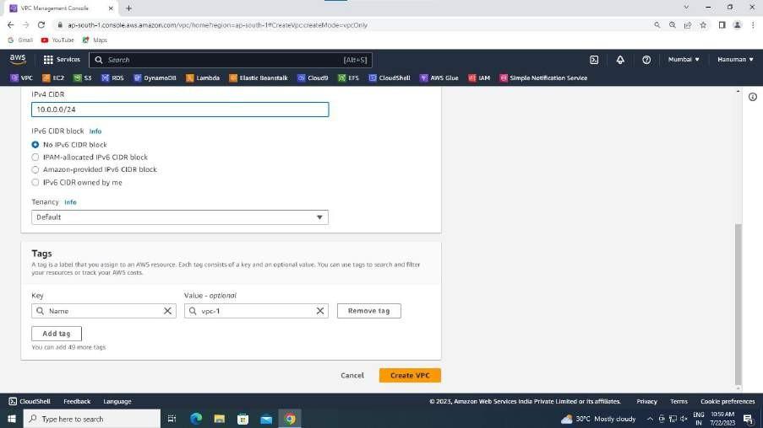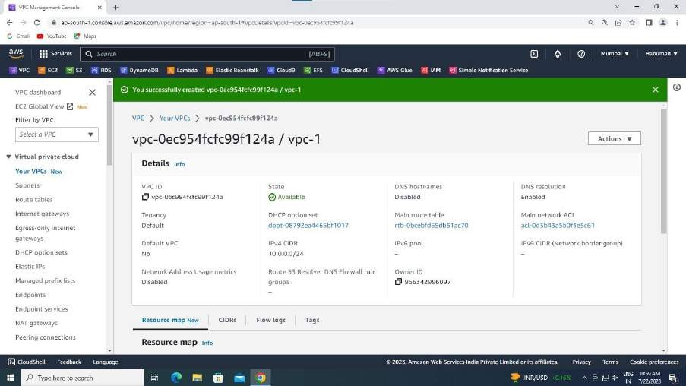

* Click on create VPC to create VPC.
* When successful the following occurs:
* Now in the left column you could see Route Tables. Click on that and edit the Route Table name as shown below (Ensure that you change the Route Table name of your custom VPC):

18

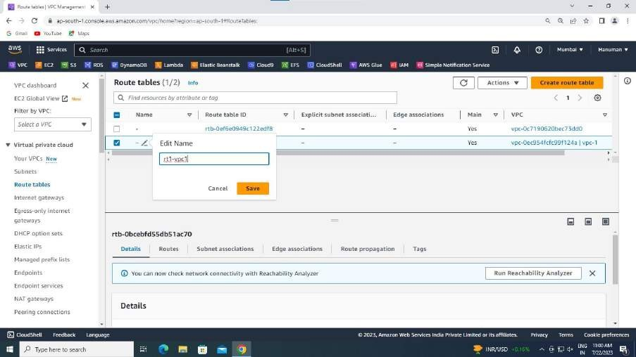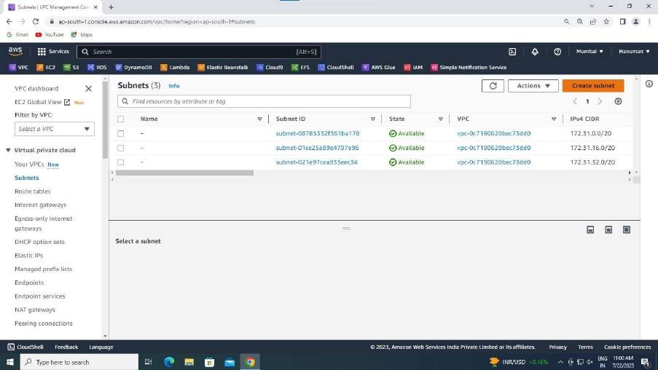

* In the left column you could see Subnets, click on that.
* You could see an orange highlighted button named Create subnet.
* Click on create subnet.
* Select your custom vpc, as shown below.

19

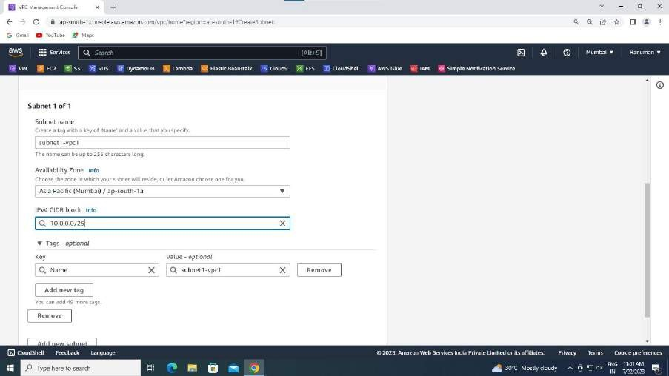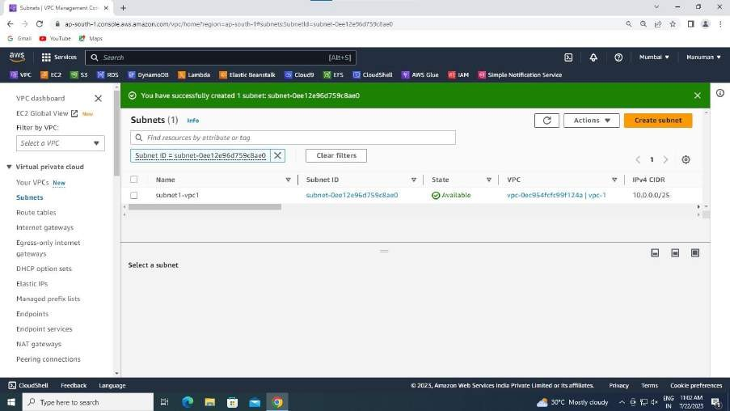

* Then settings regarding that VPC pops up.
* Give IP for subnet: 10.0.0.0/25.
* On successful creation of subnet you could see:
* Now on the left column go to Internet Gateway.
* Click on create Internet Gateway.

20

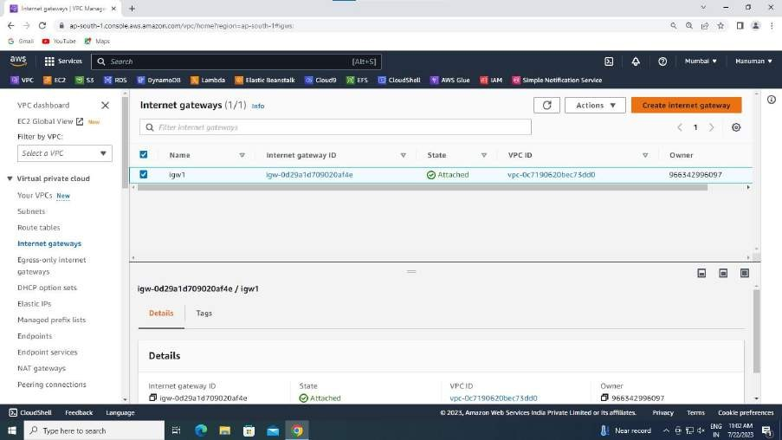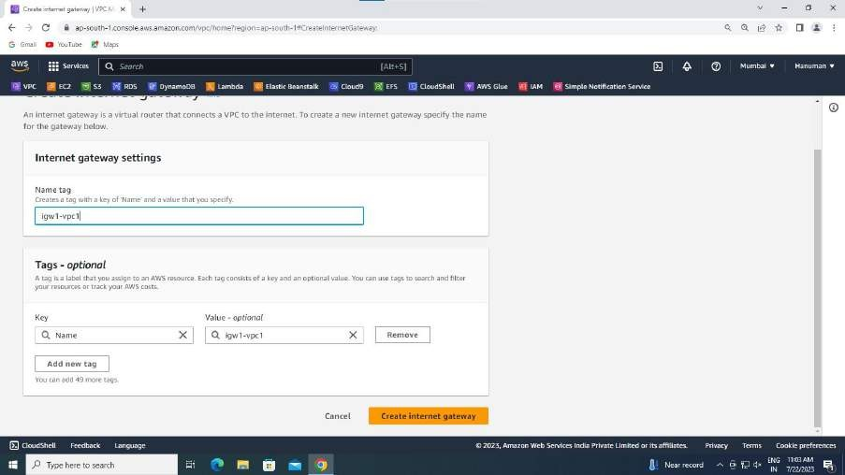

* You could see some settings popping up. Then give the name for your Internet Gateway.
* Ex: igw1-vpc1
* Then click on create Internet Gateway. If successful you could see:

21

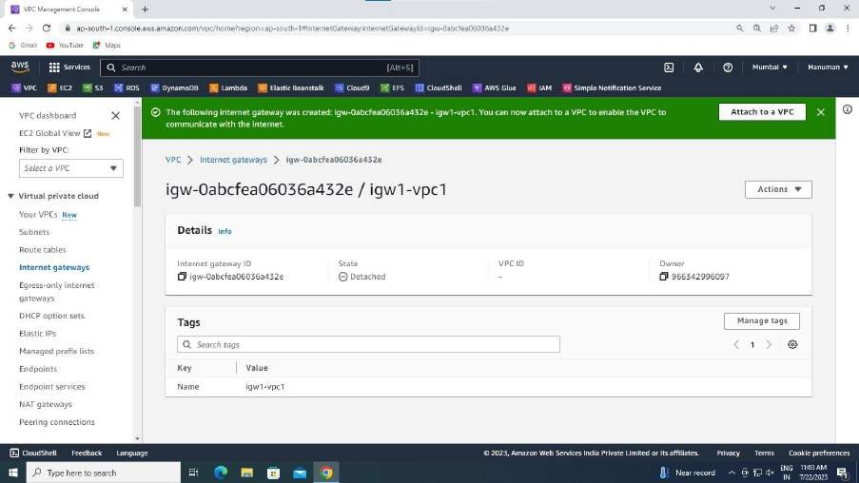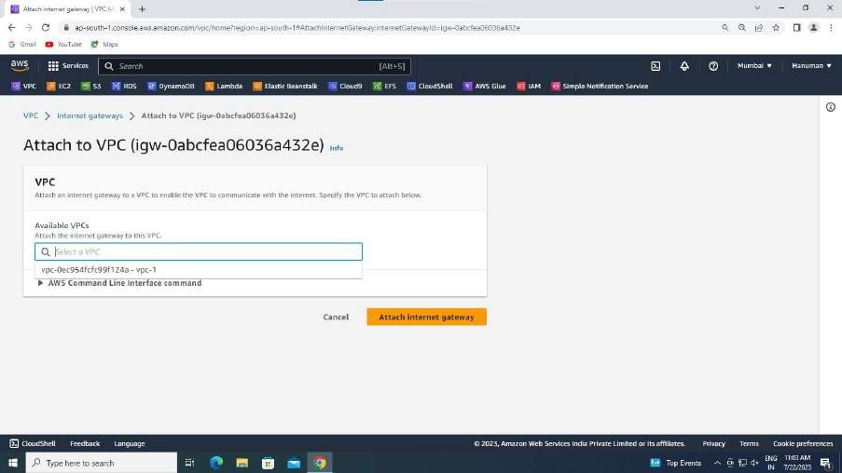

* Now you could see Attach to a VPC option. Click on it.
* You see :
* Select your custom VPC and click on Attach Internet Gateway.
* Now, go back to your Route Tables.

22

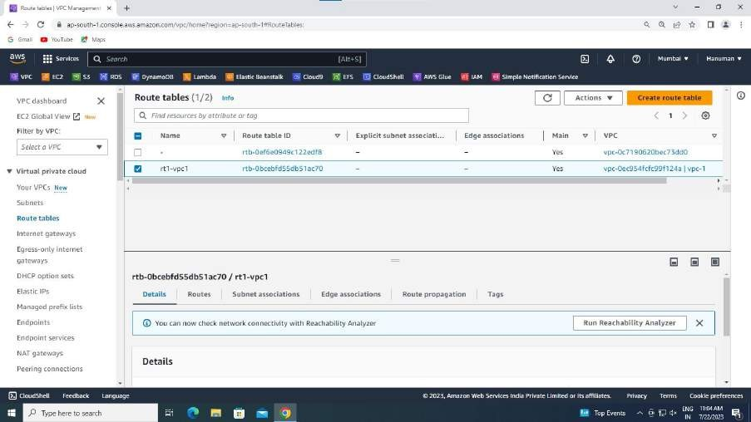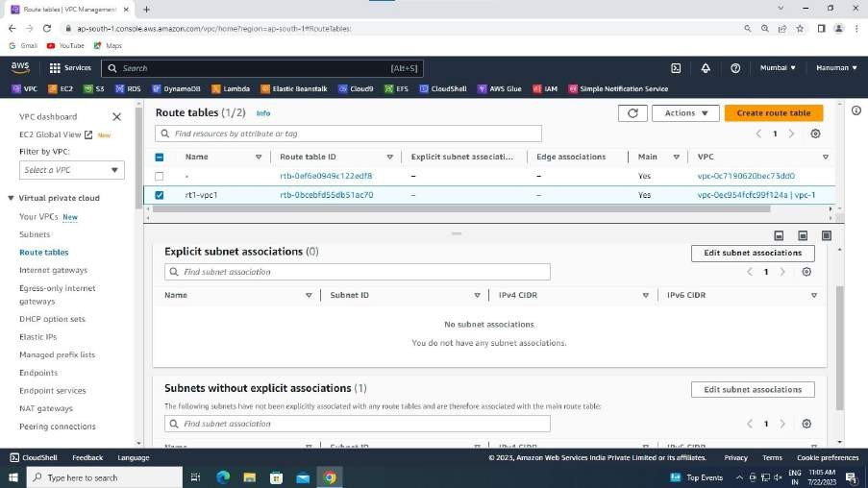

* you see Subnet associations. Click there. Then click on edit subnet associations.
* Select your subnet and click on save.

23

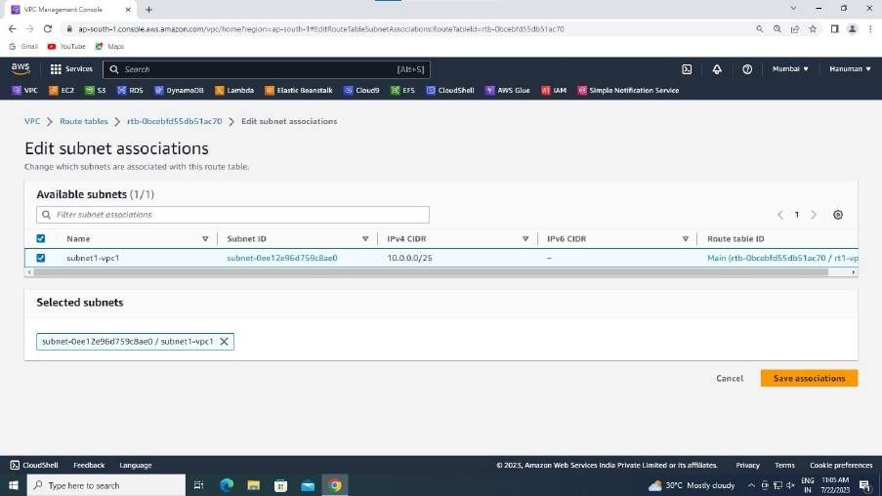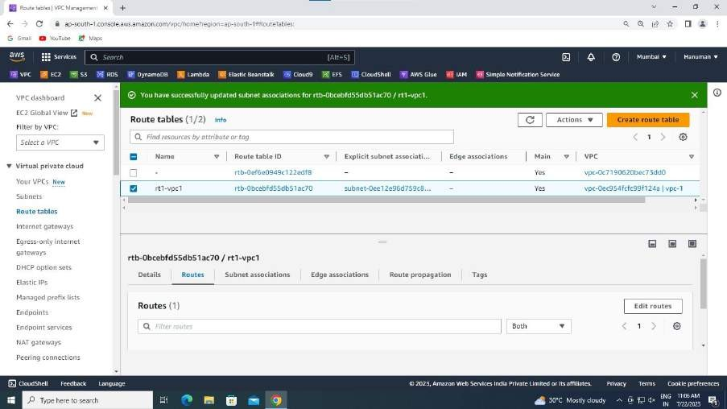

* When successful you could see a success bar in green.
* Back to Route Tables you see Routes beside subnet associations. Click there.
* Go to edit Routes.

24

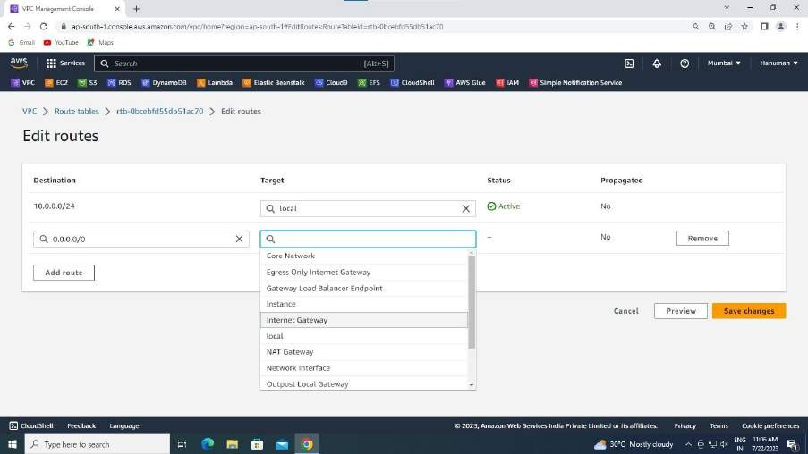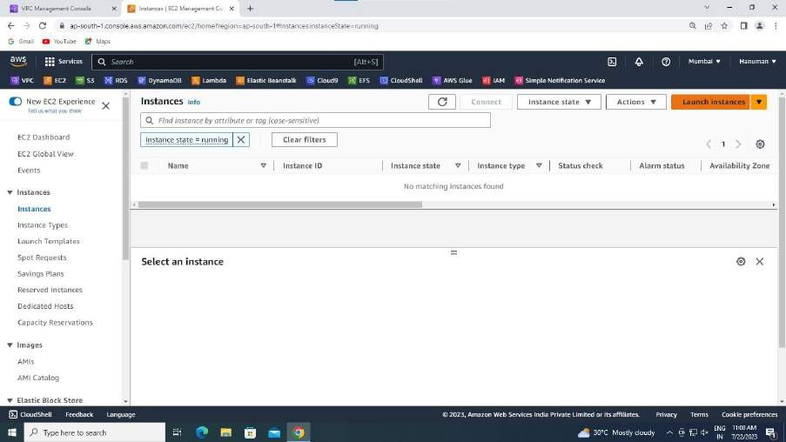

* In the Destination column give IP: 0.0.0.0/0.
* In the Target column select Internet Gateway.
* Your IG address is shown, select that.
* Click on save changes.
* Now, we are successful in creating custom VPC and its resources.
* Launch an instance in Ec2.
* Give it a name: Ex: vm1-vpc1

25

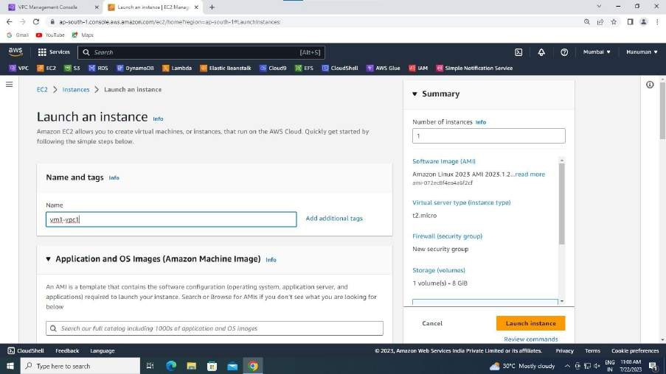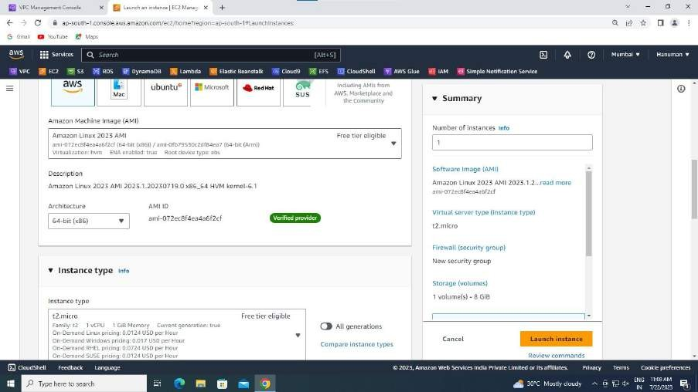

* In application and OS Images, choose Amazon Linux 2023 AMI which is free tier eligible one.
* Ensure that Instance Type is t2-micro.

26

* Select Key Pair (Existing one. If there is nothing in existing column click on create new Key Pair,give it a name, choose .pem and click on create).

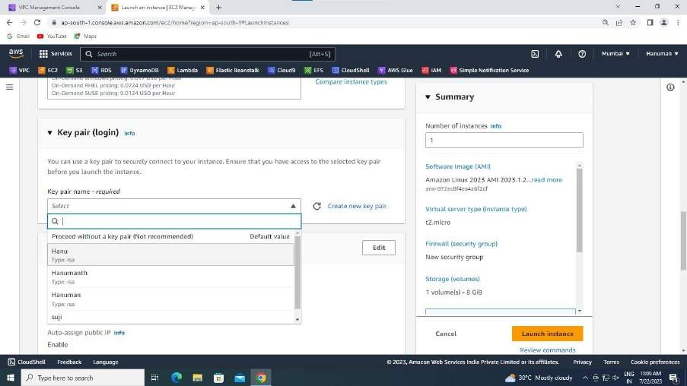

* Go to Network Settings.
* Select your VPC.
* Choose subnet assoiciated with your VPC.

27

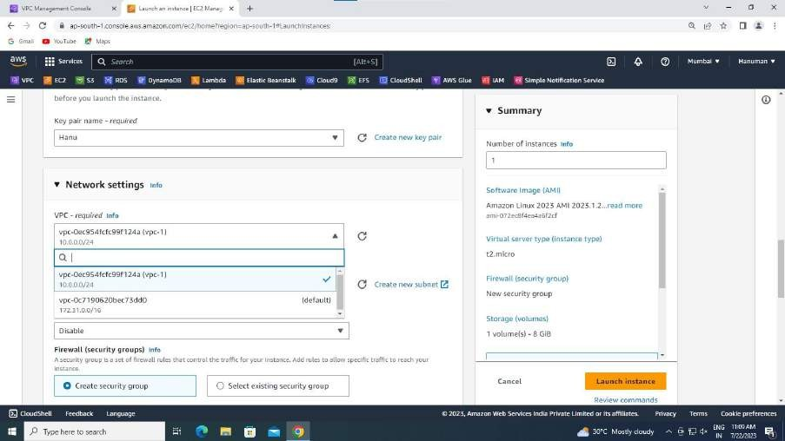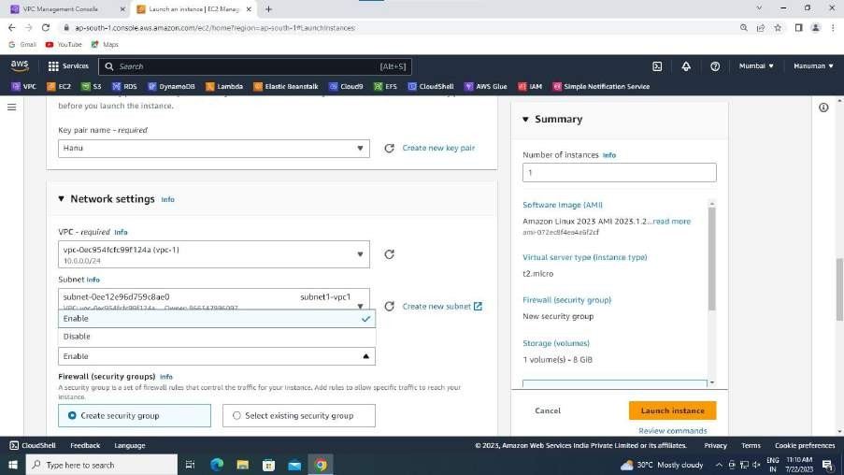

* + Enable the Public IP.
  + Click on Create Security Group.
  + Give it a name: sg1-vpc1

28

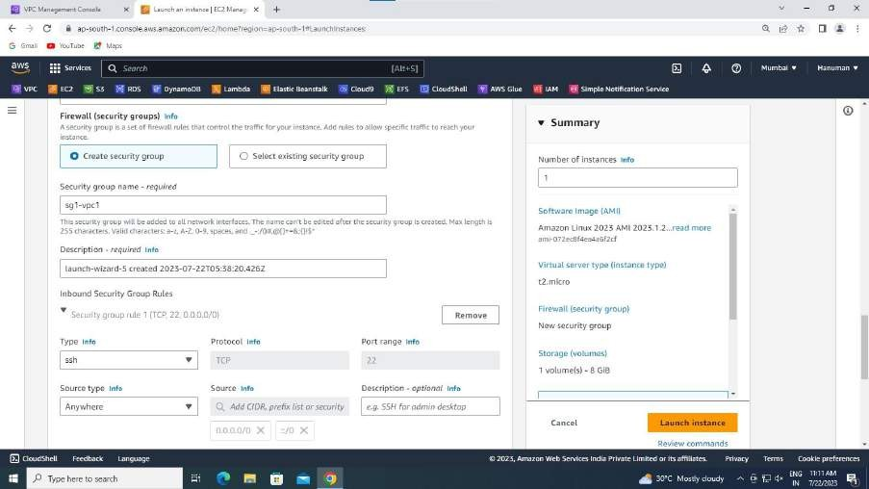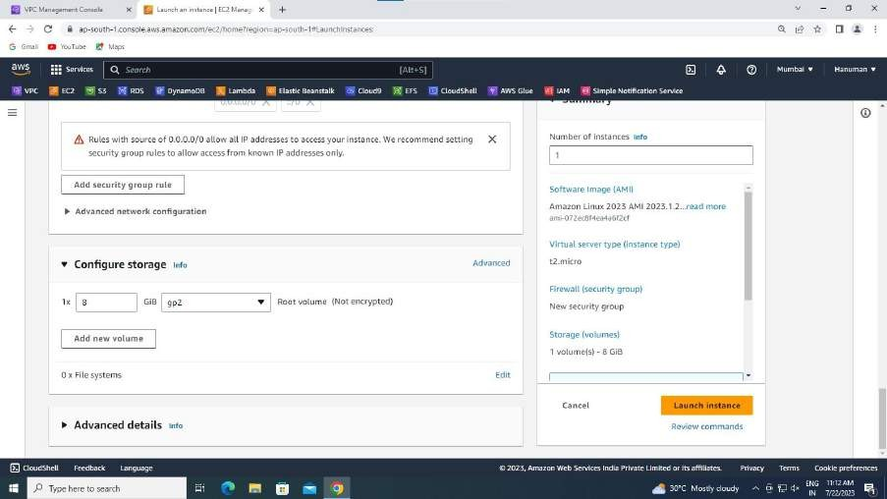

* Give Inbound Security Group Rules: 1. TYPE: ssh ; SOURCE: Anywhere.

2.TYPE: All Traffic ; SOURCE: Anywhere.

* In Configure Storage change root volume to gp2.
* Successful instance creation results in:

29

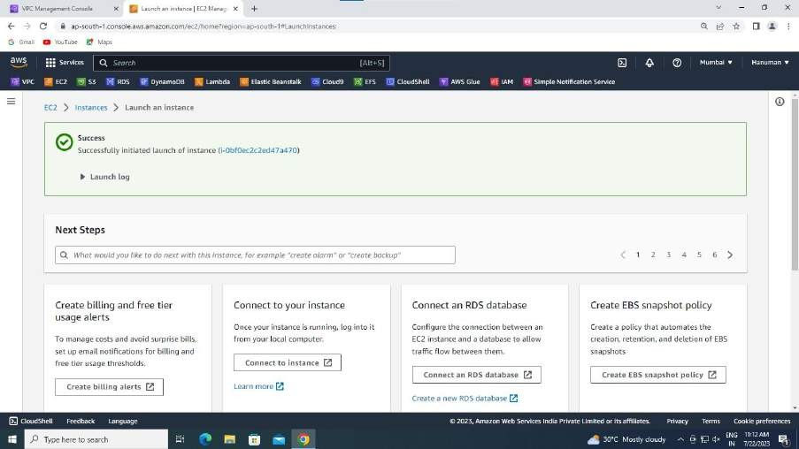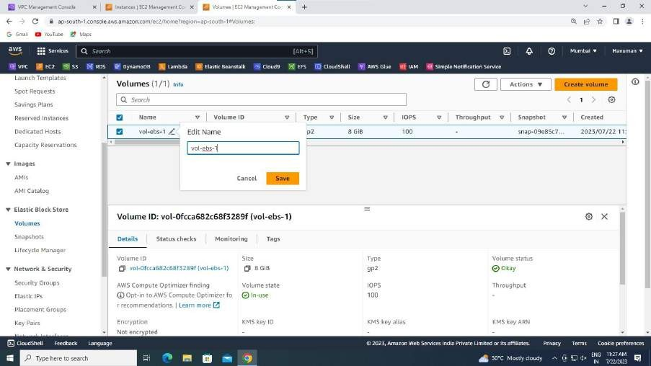

* CREATING VOLUME:
  1. In the left side column ,go to Elastic Block Store. Then open volumes in new tab.
  2. Then rename it. Then right click and select create volume.
  3. In volume settings change size to 10 GB.
  4. Check Availability Zone is same or not.

30

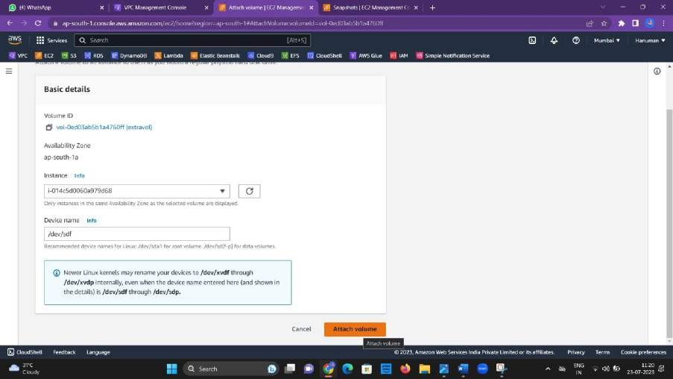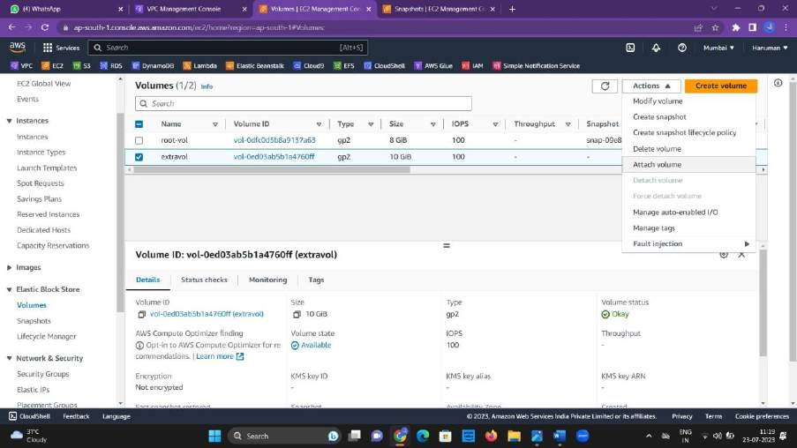

* 1. Create volume.
  2. Rename it to extravol. So, now extra volume is created.
* CREATING SNAP SHOT:

1. Select extravol, go to Actions.
2. Click create SnapShot.

31

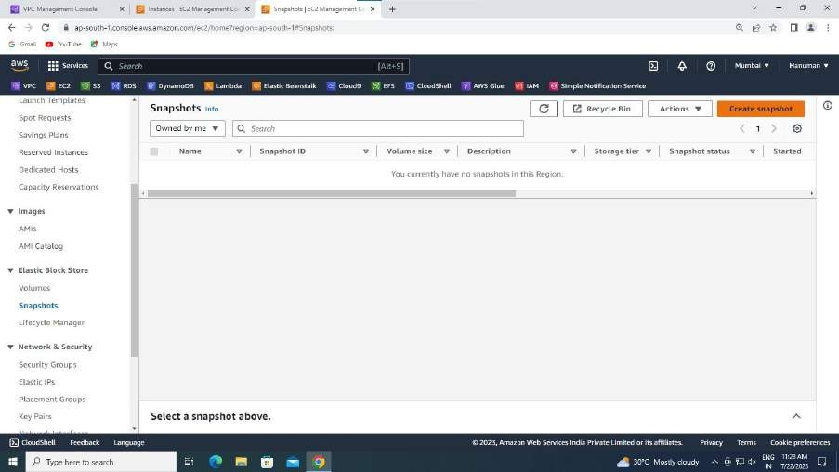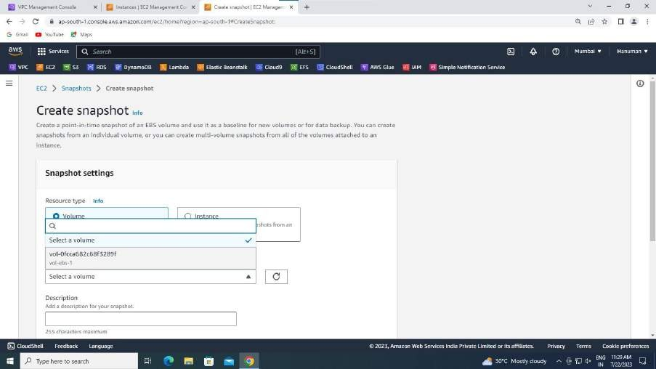

Select your volume:

32

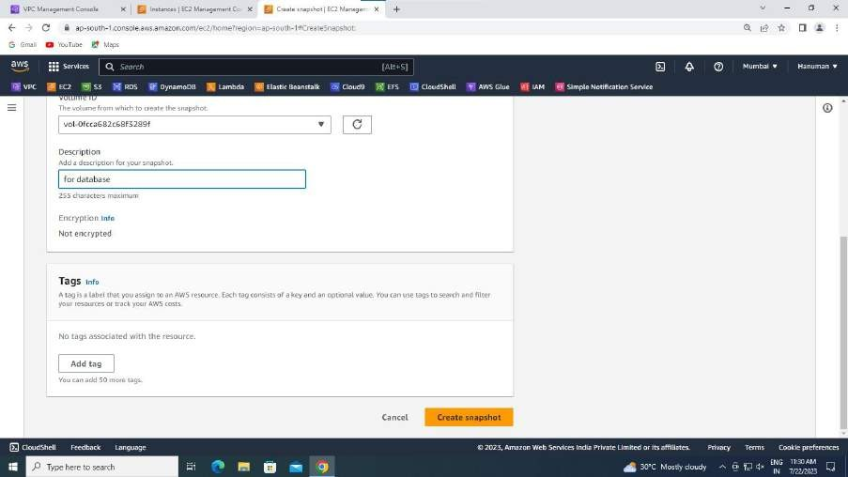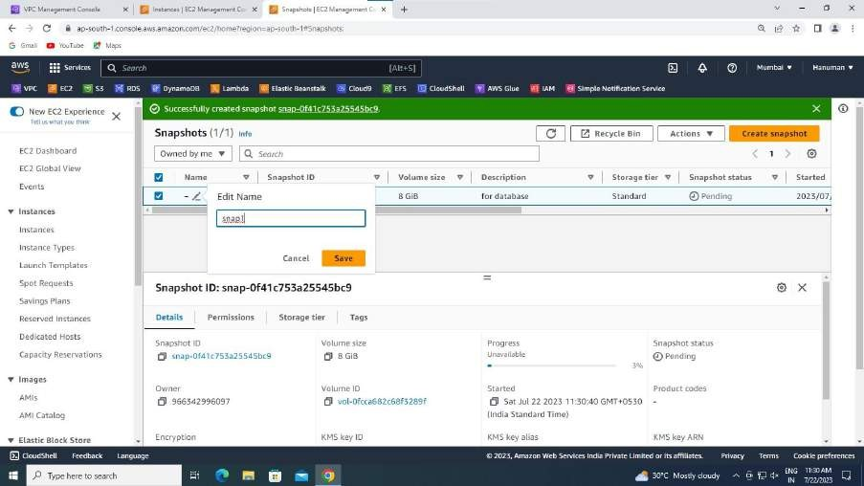

1. Go to SnapShots in left column in Elastic Block Store.
2. Check the created snapshot.
3. Rename it.

Go back to instances and connect your instance.

33

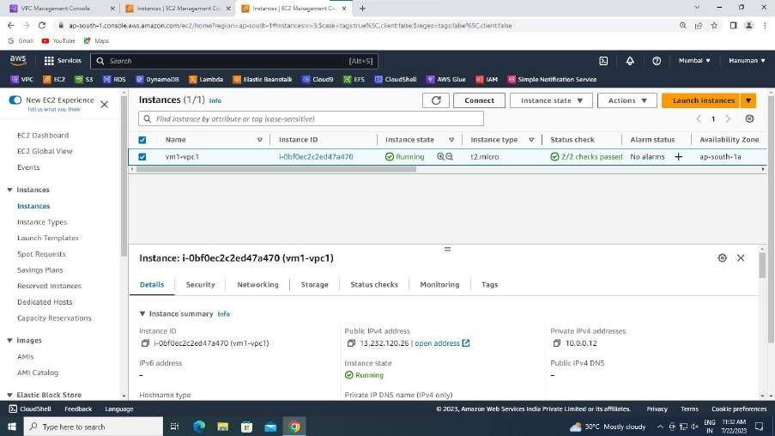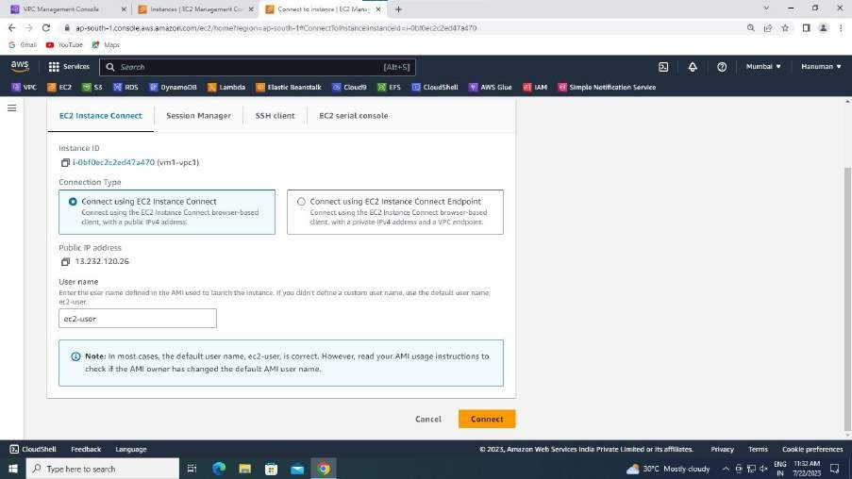

Connecting…

A black console appears as if:

34

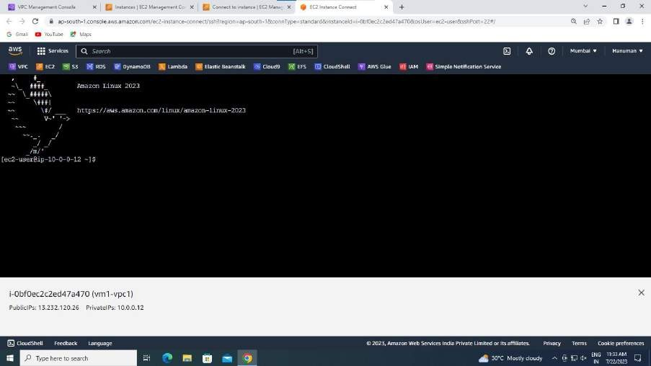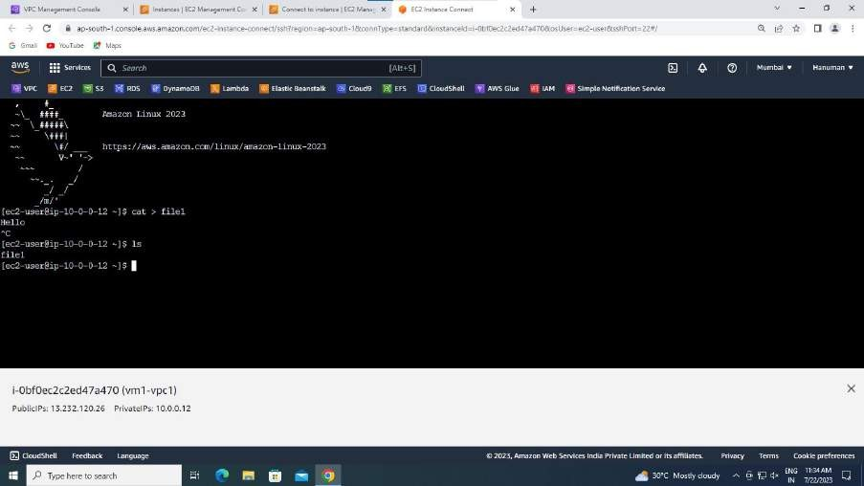

Enter the following commands:

Now back to Snapshots… select your Snapshot and go to actions and choose copy Snapshot.

35

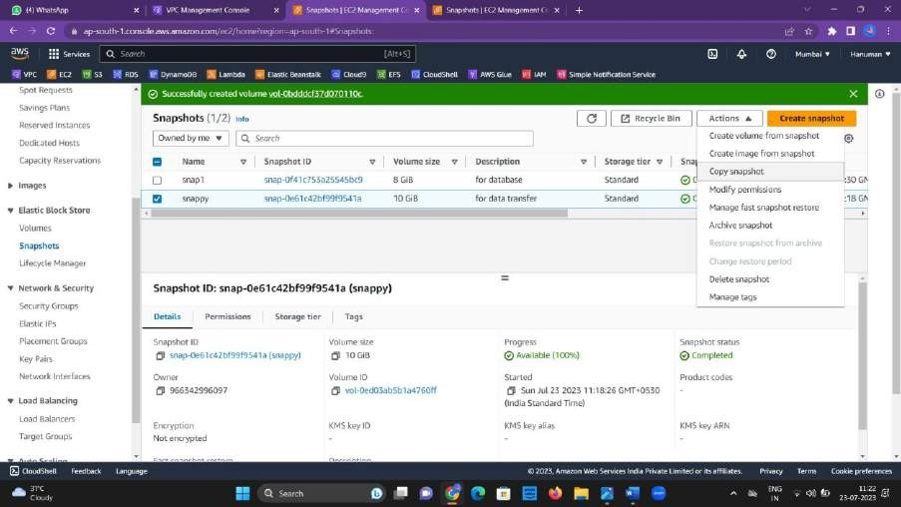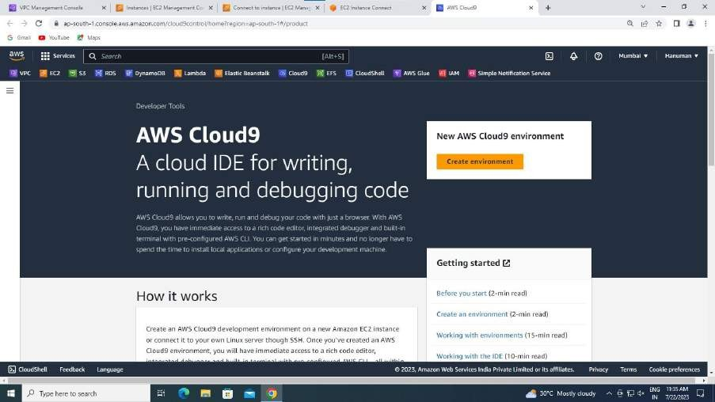

CONSTRUCTION OF CLOUD 9:

* Search for cloud9 in search bar and open.
* Click on create environment.

36

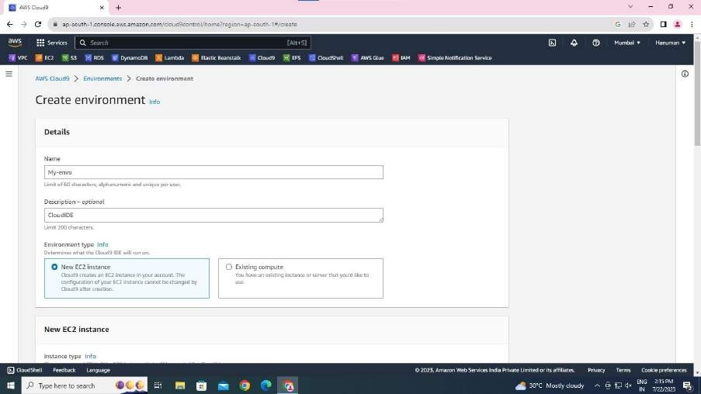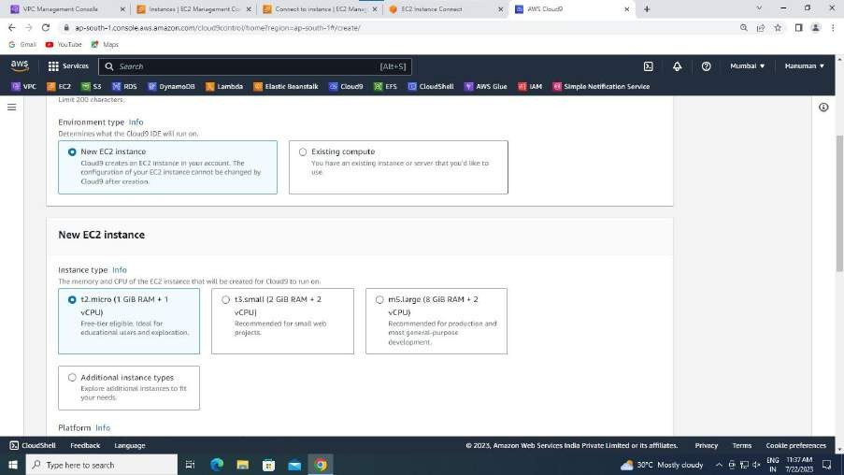

* Give name : My-envo.
* Desc : for architect.
* Select New EC2 instance.
* T2.micro(1 GiB RAM +1 Vcpu)

37

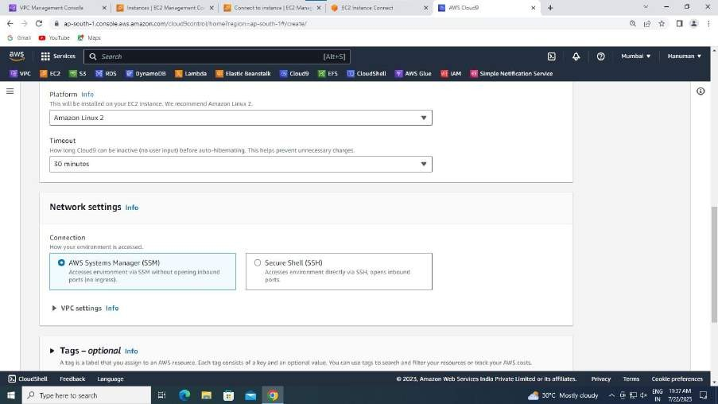

* Choose AMI Linux platform
* Let timeout be 30 min.
* Choose SSM in Network settings.
* Choose your VPC in VPC settings in connection of Network Settings.

38

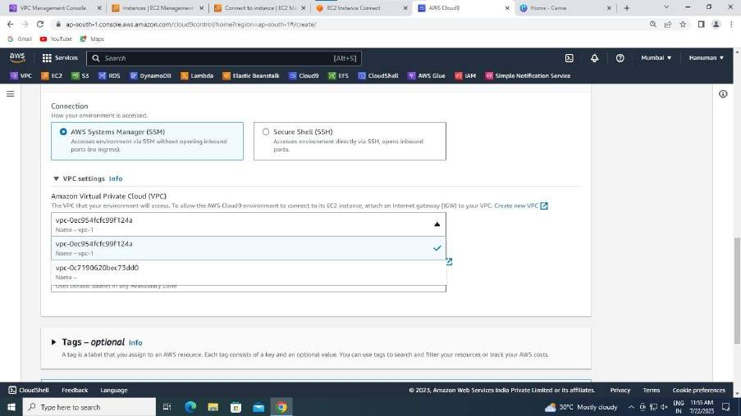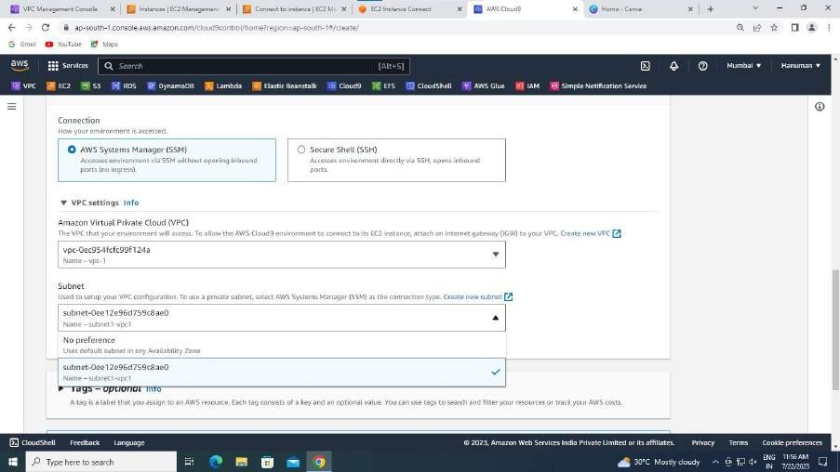

* Then the next step is to choose your subnet.
* Then click on create.

39

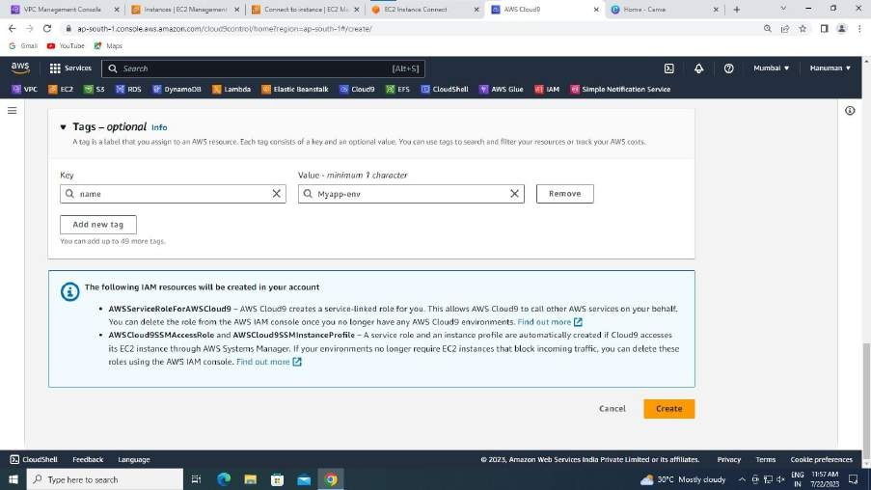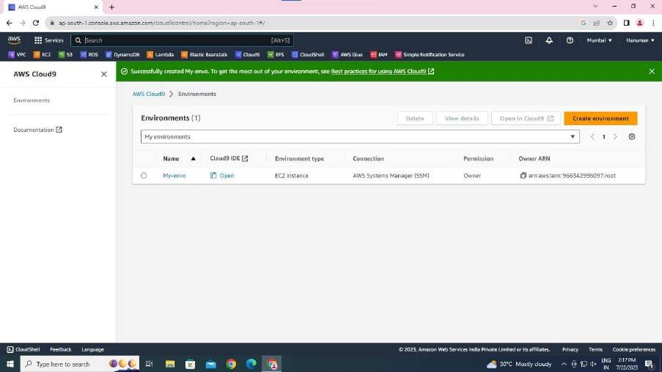

* your new environment of cloud 9 is created successfully.
* Go back and check your instances , you could see an automatic instance created by creating cloud 9 environment.
* It is displayed below:

40

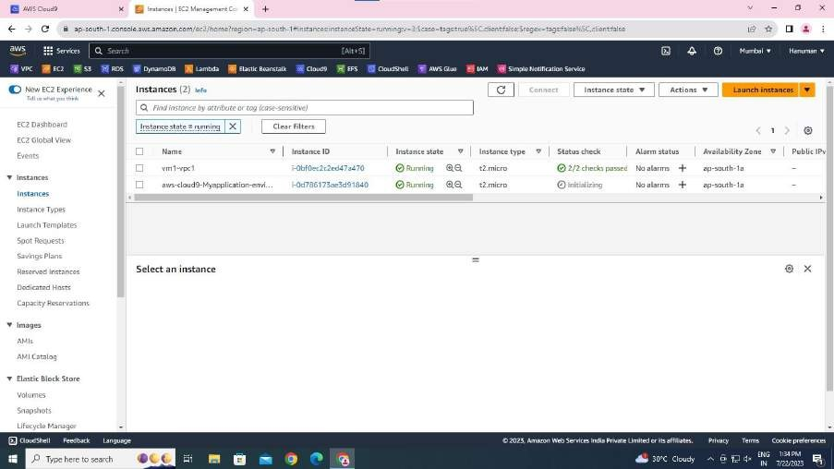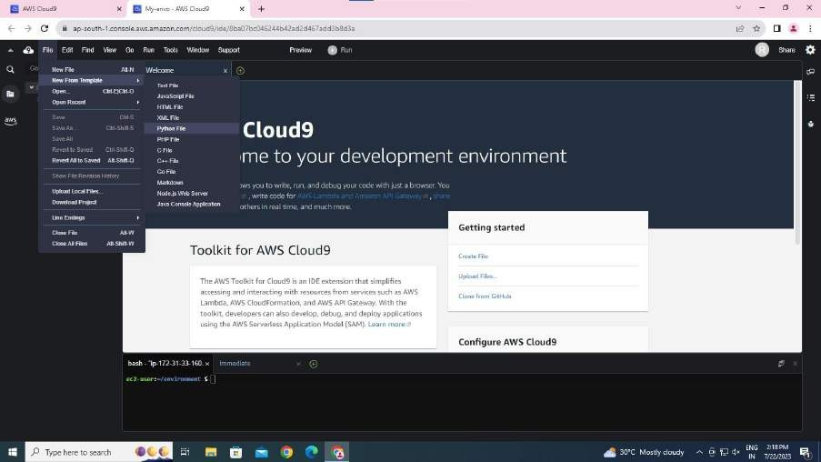

* + Now in the cloud 9 environment, go to your environment,click on file,go to new template,and choose python file:
  + The enter the following commands in the EC2-user environment:
  1. cat
  2. ls

41

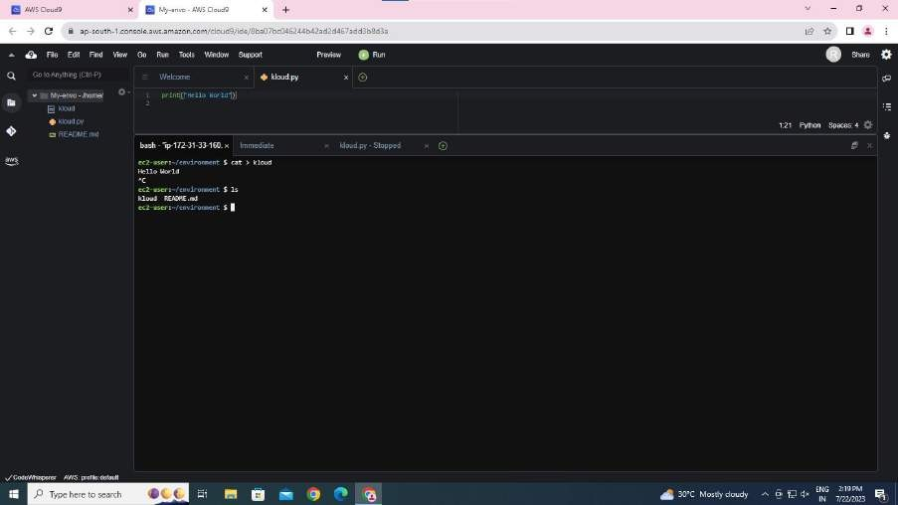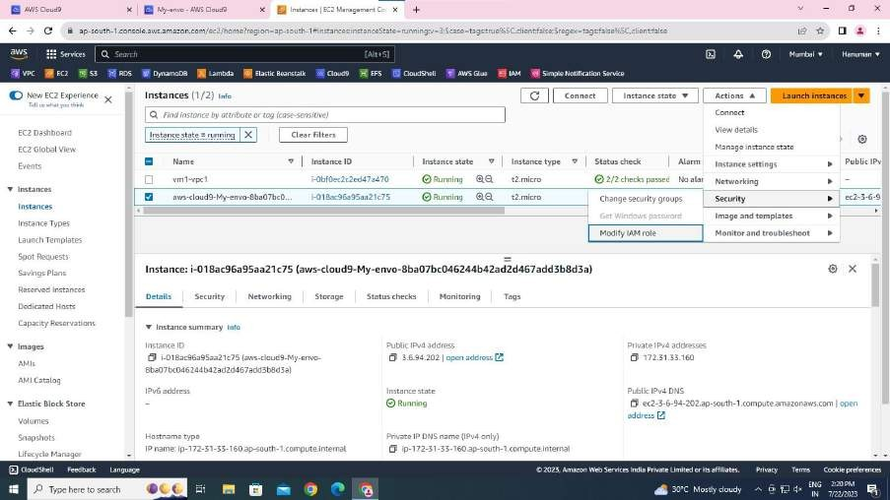

* + Back to the instances,select the Cloud9 instance and go to actions, in Security you will find modify IAM click on it.
  + Choose Cloud9 AMI and update it.

42

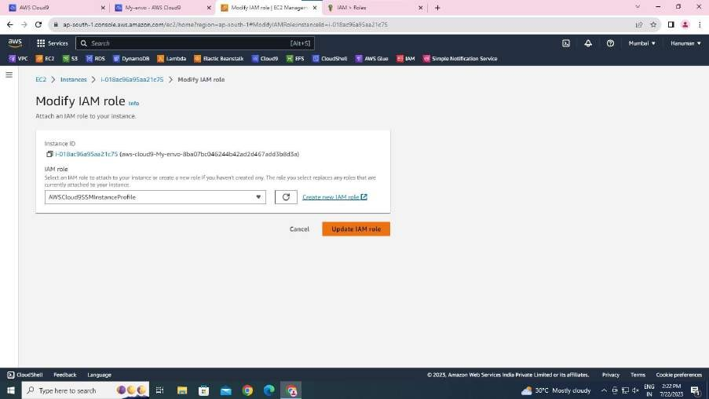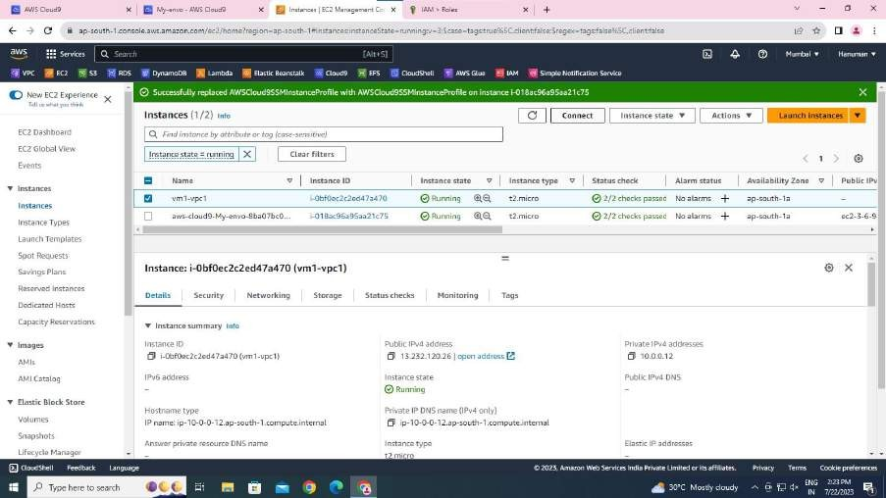

* + We are done creating VPC in one region,then creating Cloud9 environment for it and creating IAM role. The part left for these is checking whether the construction of architecture is

successful in Data Transfering or not.

* + So now back to instances.

43

* + connect your EC2 intance and check whether the data in the Cloud 9 instances is transferred to this instsnce or not.

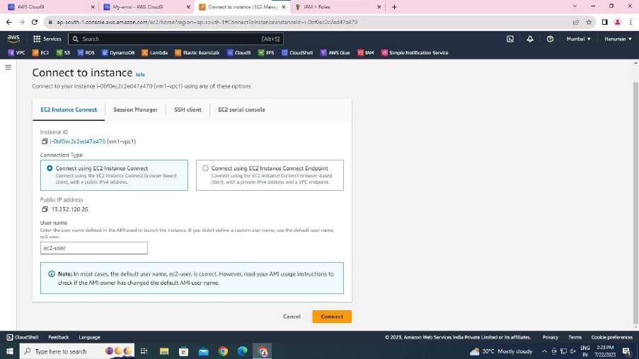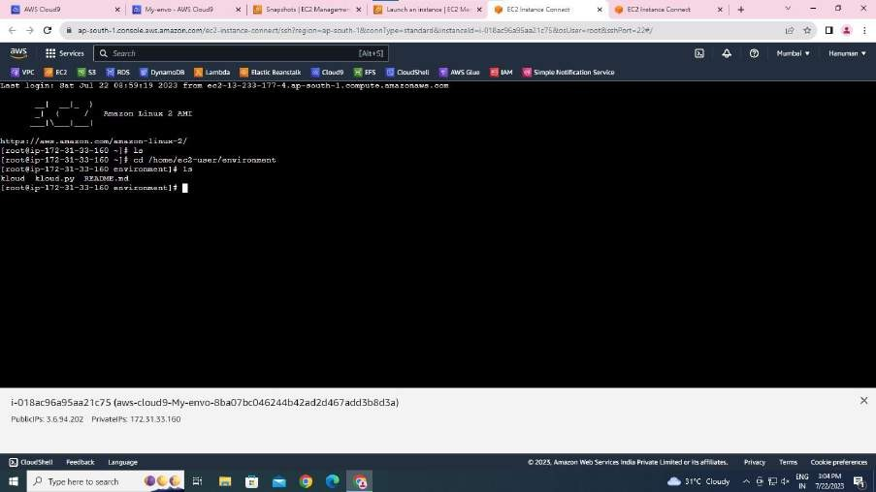

* + This can be done by entering the following commands:
  + You had observed that the files in Cloud9 can be seen here.
  + It means we are succesful in data transferring.

44

**IN THE OTHER REGION**:

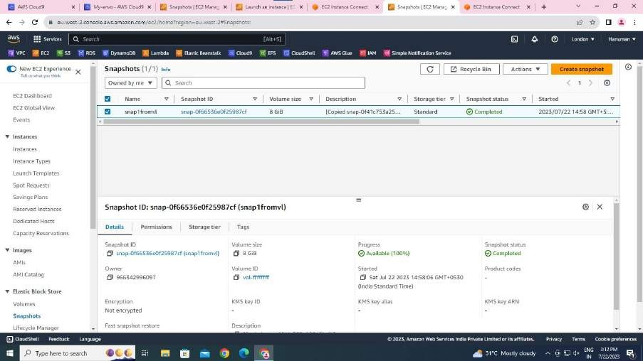

On before hand go to Snapshots and rename the copied snap for let go further confusion.

* Construct the VPC as the previous one.
* Similarly create subnet.
* Edit Route Table name and select it.
* Edit Subnet Associations, and save it.
* Create Internet Gateway.
* Attach it to VPC.
* Edit Routes, add Routes and save chages.

GO TO EFS :

45

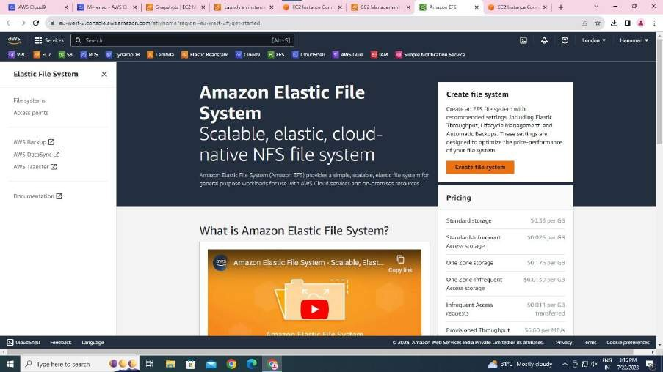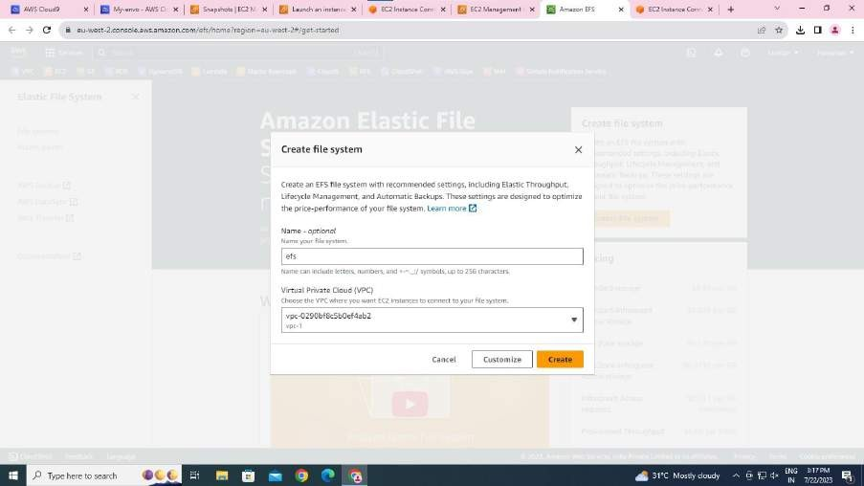

* Click on create File.
* Name it.
* Select your vpc. Click on create.

It shows:

46

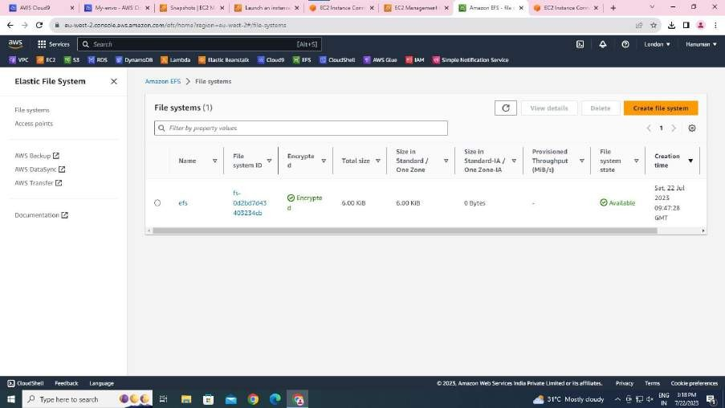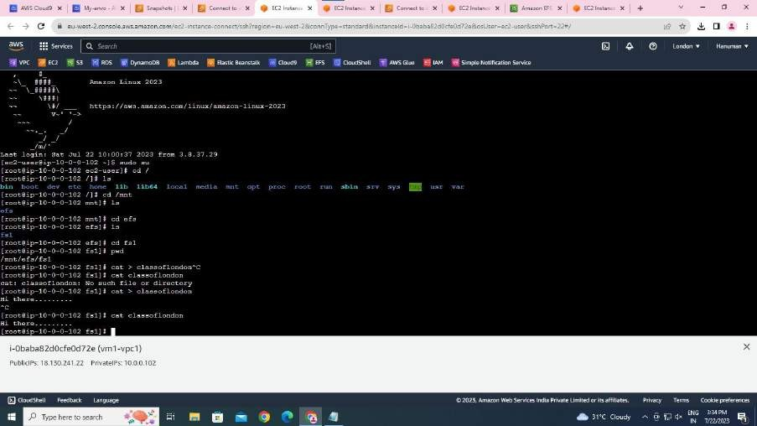

* Connect the instance linked with EFS and enter the commands to ensure Data Transfer:

47

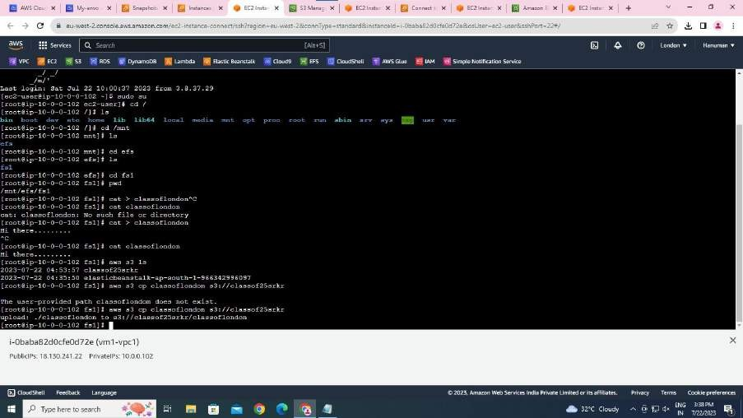

LAUNCHING INSTANCE:

* Launch the instance similar to the previous one.
* Give it a name. Ex:vm1-vpc1
* Select keypair.
* In Network Settings choose your VPC, your Subnet.
* Enable Public IP.

ATTACHING COPIED SNAPSHOT TO INSTANCE WHILE CREATING INSTANCE:

* In Configure Settings click add new volume.

48

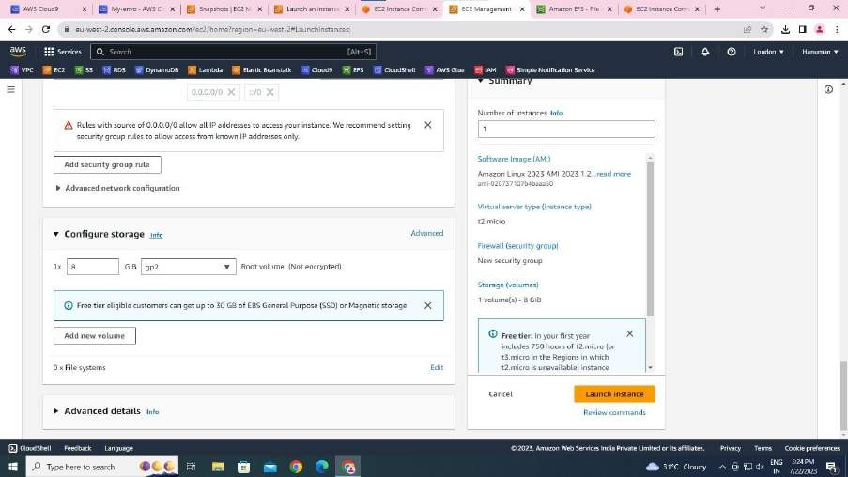

* Select your snapshot ID.
* Change size to 10 GB.
* Now launch instance.

FOR THE CONSTRUCTION OF EFS FOLLOW:

* Go to EC2.
* Create instance
* In Storage info, go to File Systems
* Select EFS.

49

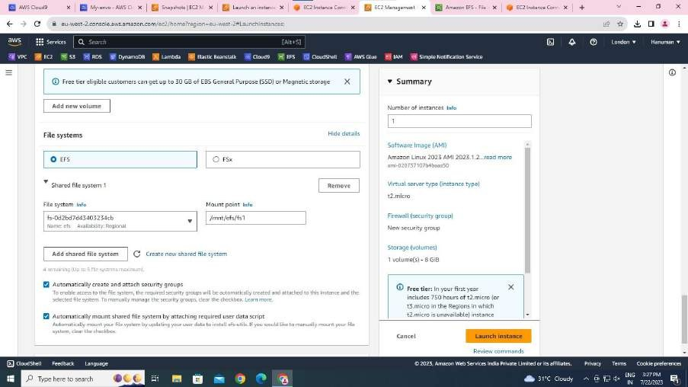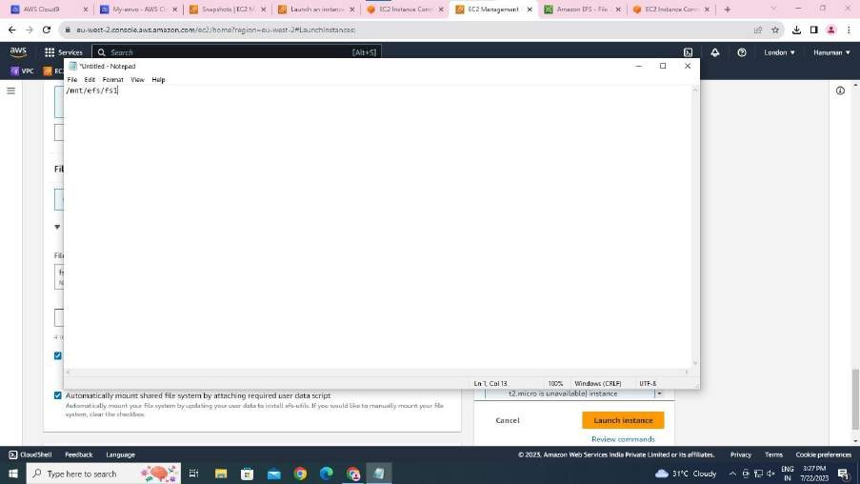

* copy mount point.
* Launch an instance.

50

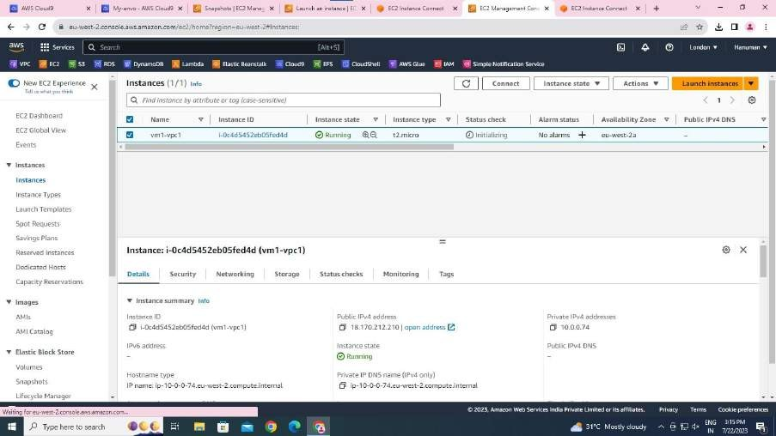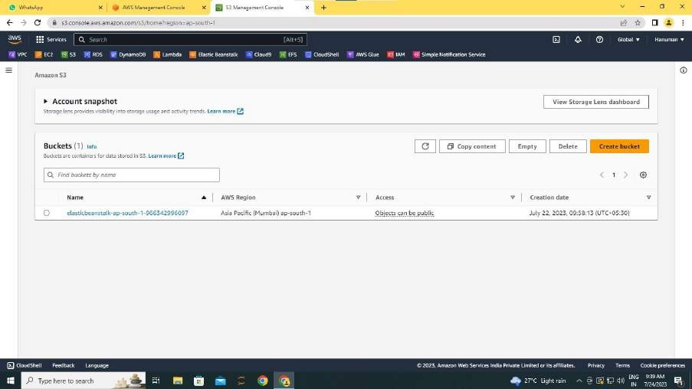

GO TO S3 CONSOLE:

* Go to Buckets.
* Click on create Bucket.

51

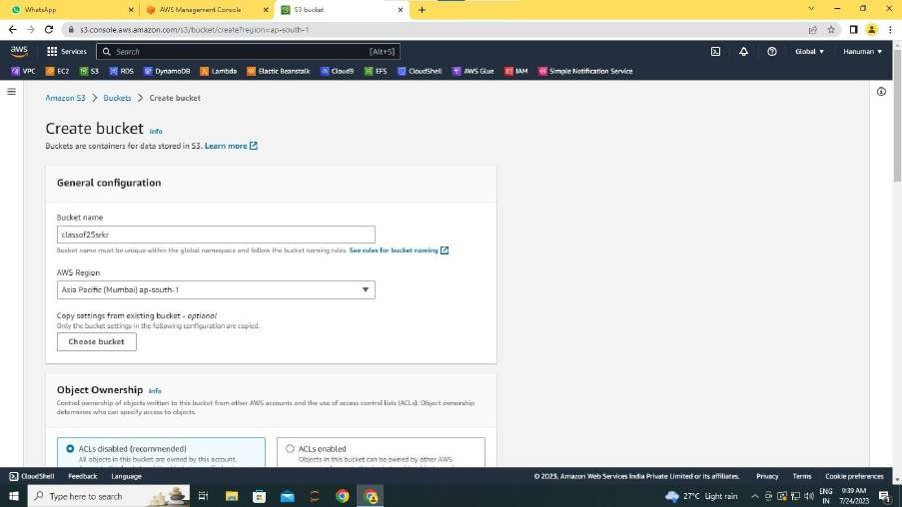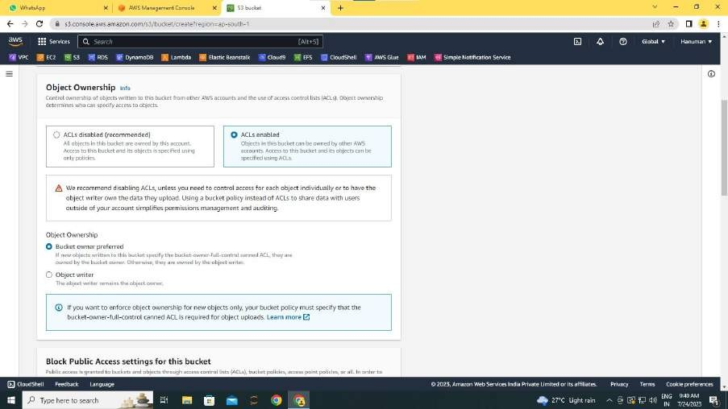

* Give it name, specify your region.
* Enable ACL permissions.
  + Deselect all the Public Accesses.

52

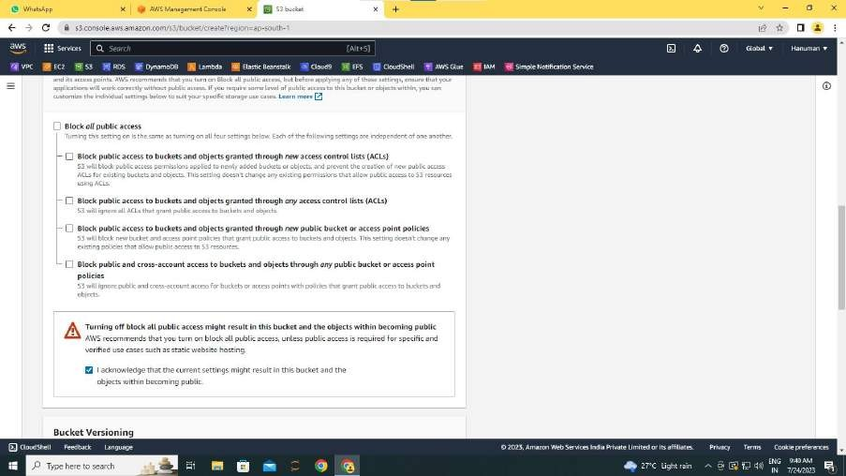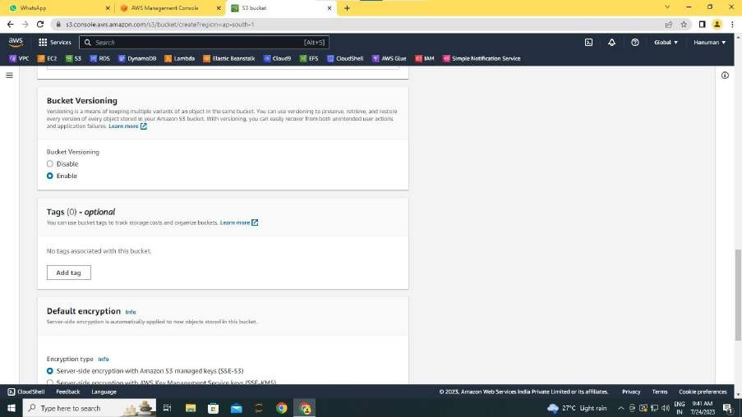

* + Enable the bucket versioning.
  + Go on ..!! click on create.

53

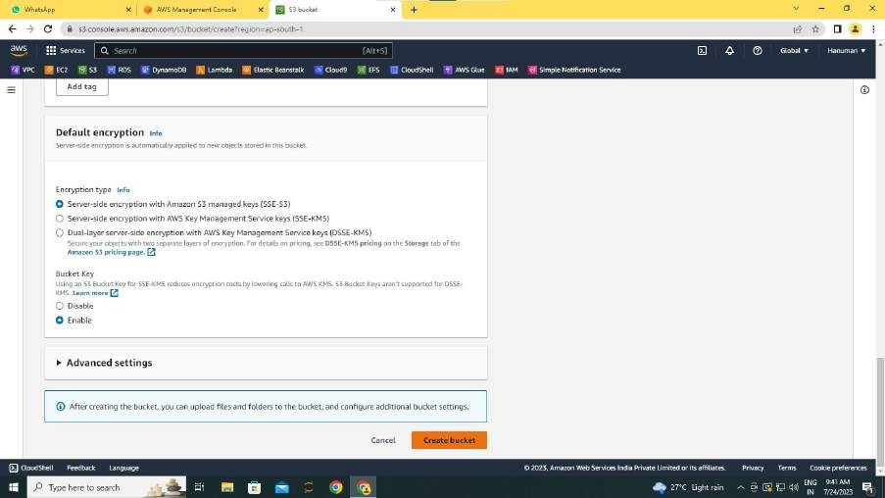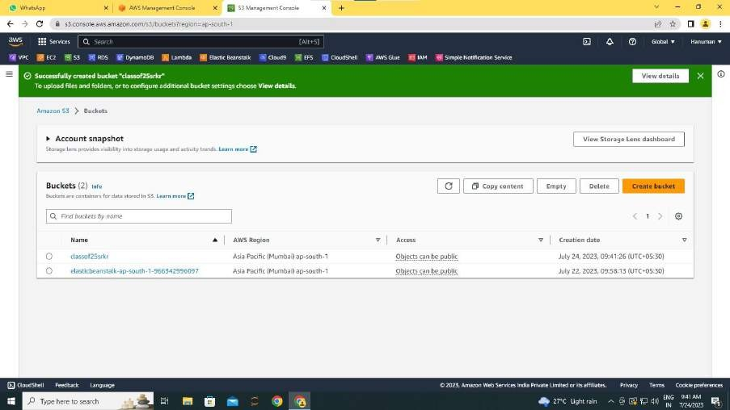

* + Yeah !! successful in creating bucket.
  + Go to your bucket…

54

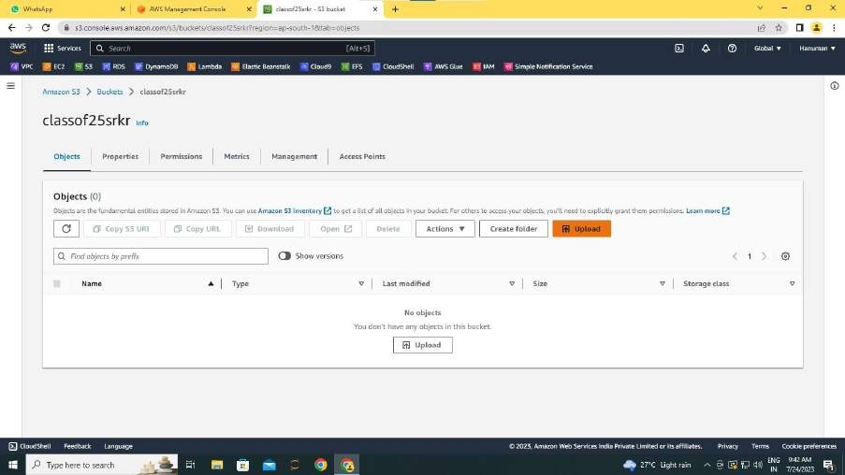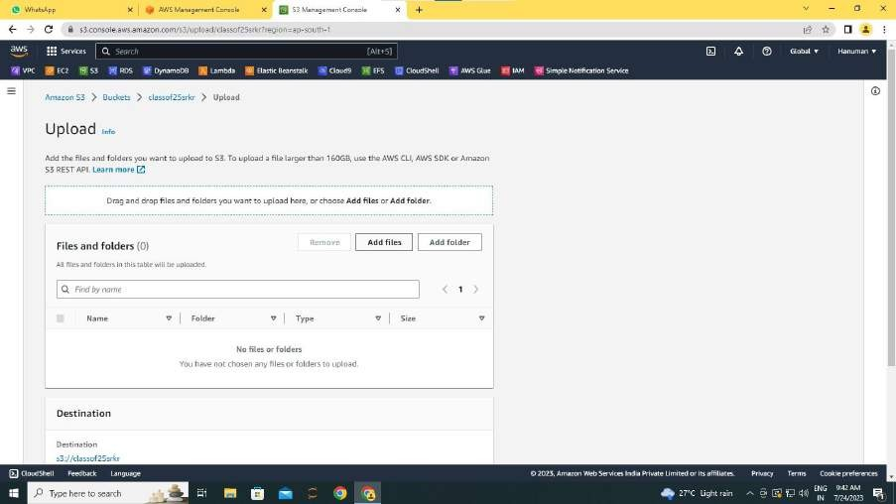

* + Upload any file there. This could be done by clicking on uplaod,then selecting your required file.

55

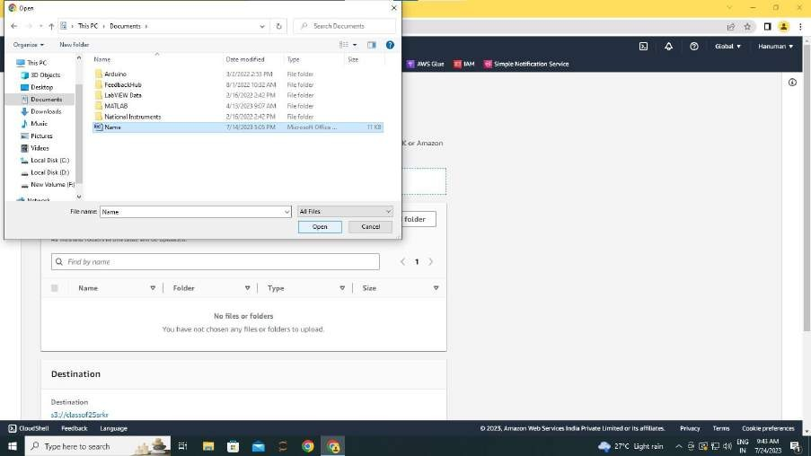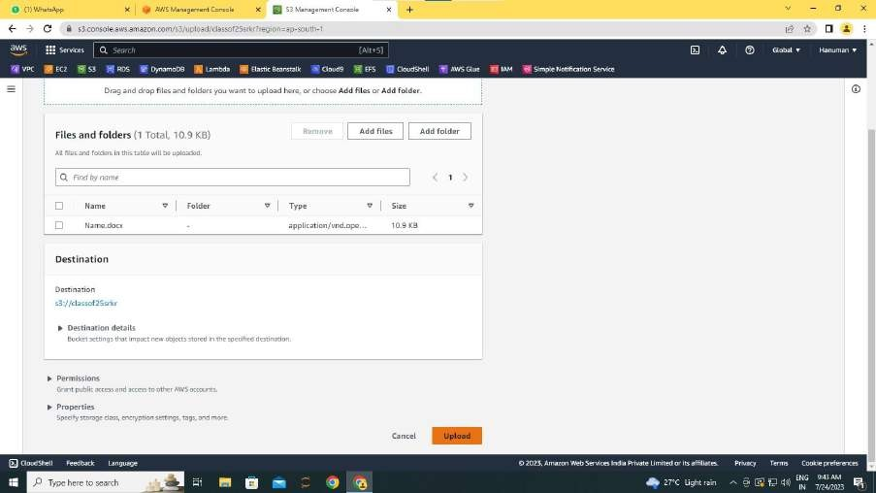

* + If you are successful it displays:
  + Go to roles in IAM

56

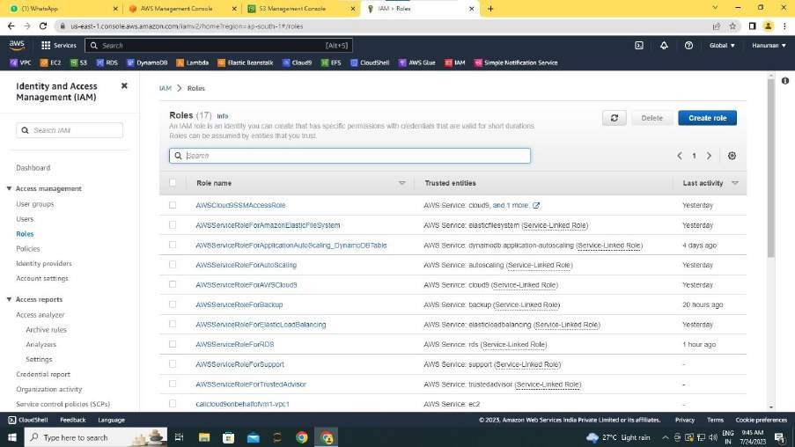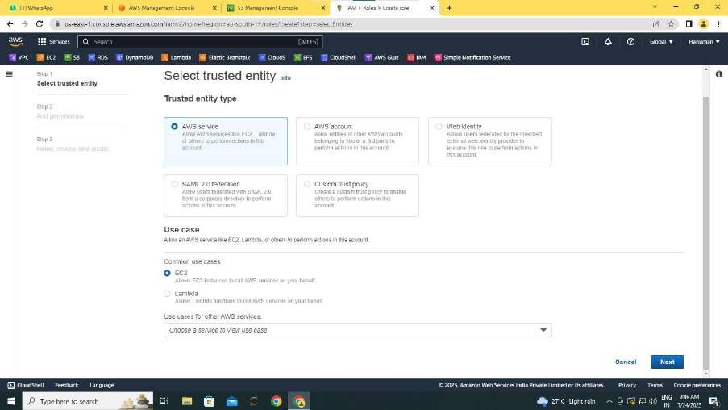

* + Click on create role.
  + Select use case EC2.
* In Permissions search for AmazonS3FullAccess. And select it.

57

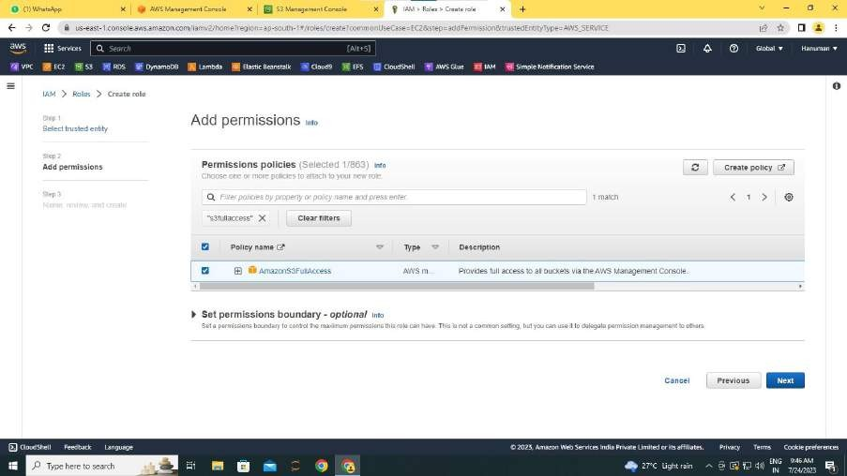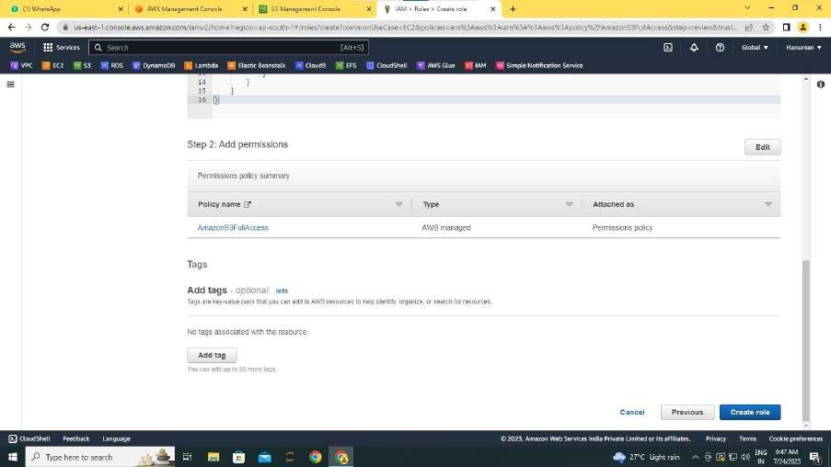

* Click on next.
* Click on create Role.
* If you are successful it shows:

58

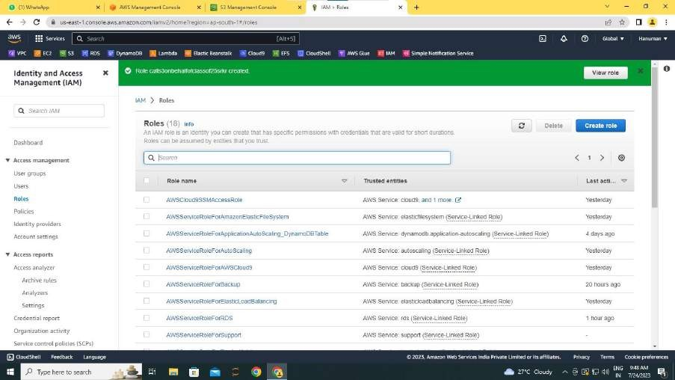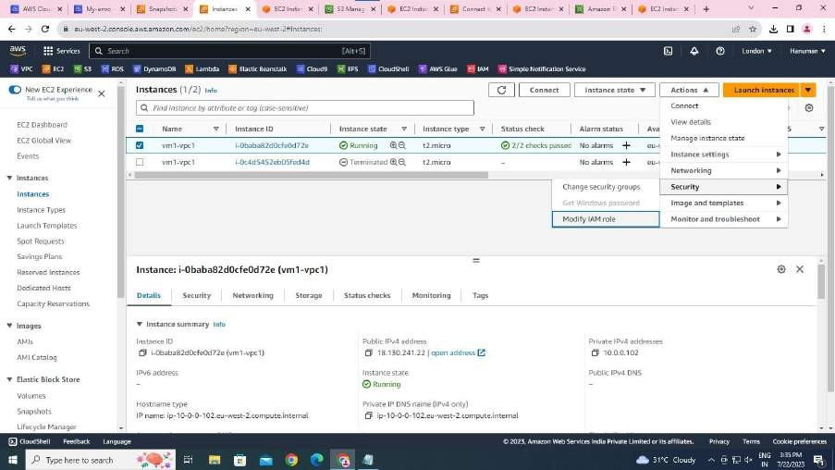

Now select your instance,

* In Actions – Modify IAM Role, select S3 Role.
* And update it.

59

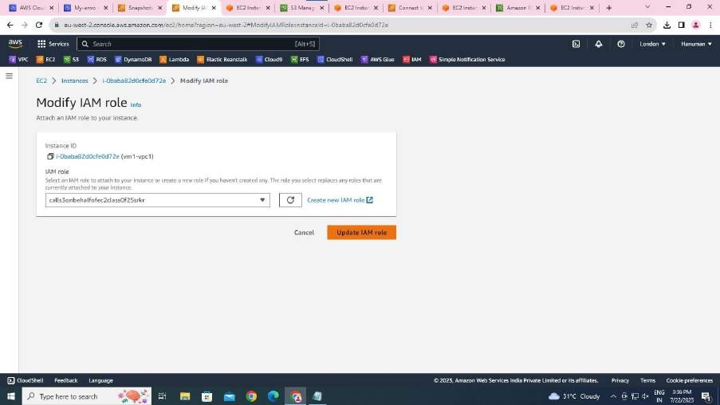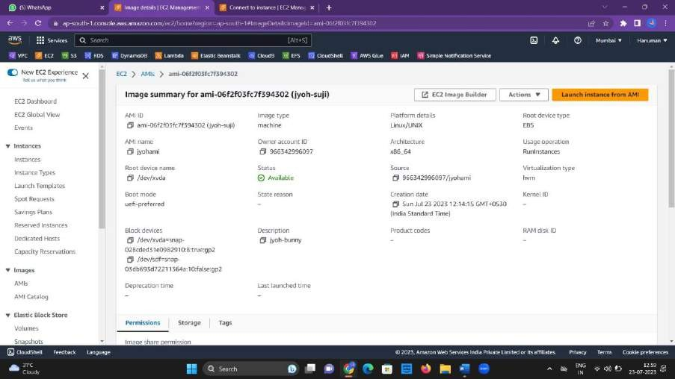

IN THE FIRST REGION GO TO AMI’S AND CREATE ONE:

After creating AMI select it go to actions and choose Copy AMI.

60

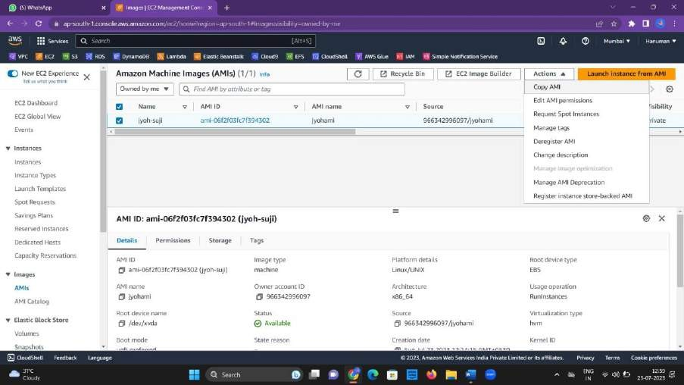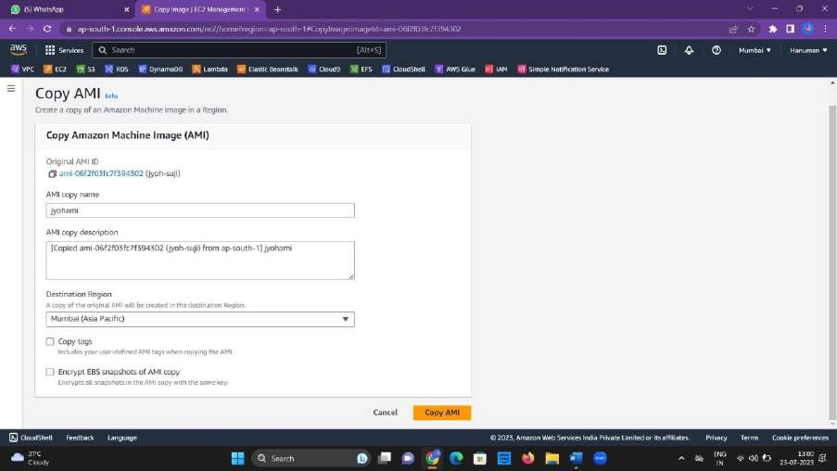

* Give a description.
* Select your other region.

61

IN THE FIRST REGION ITSELF CONNECT THE INSTANCE AND ENTER:

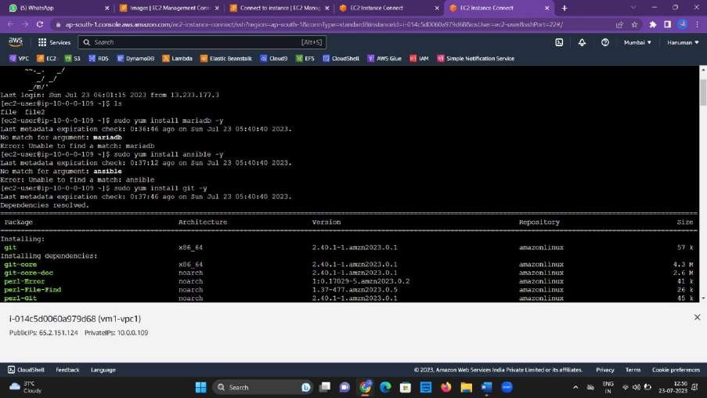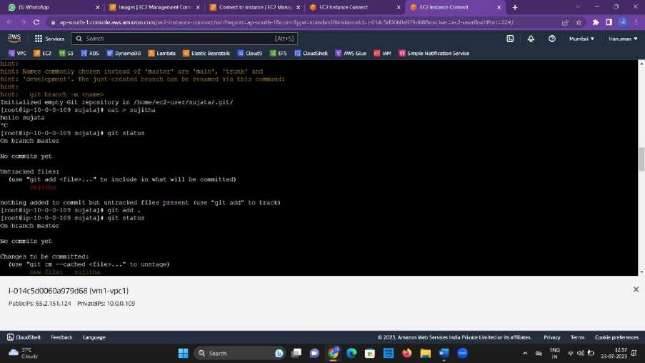

62

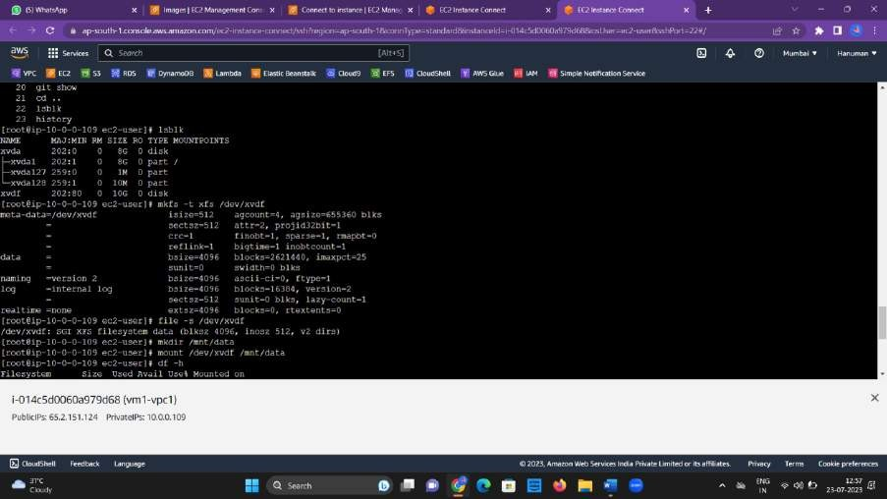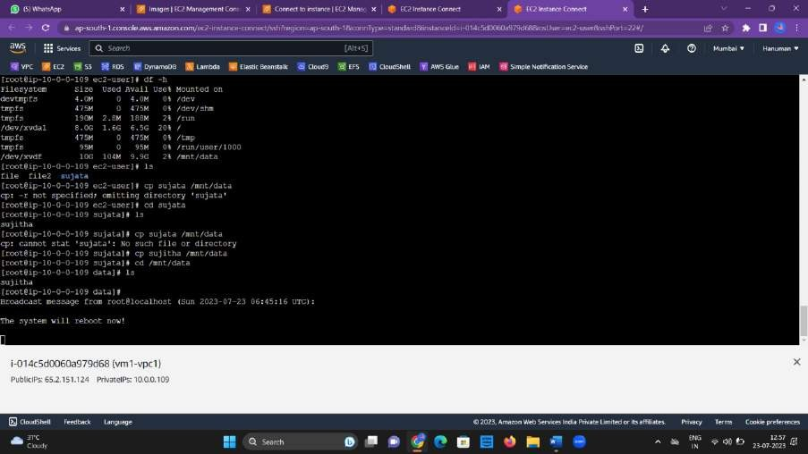

IN THE SECOND REGION CONNECT YOUR INSTANCE LINKED WITH COPIED SNAP AND COPIED AMI AND ENTER:

63

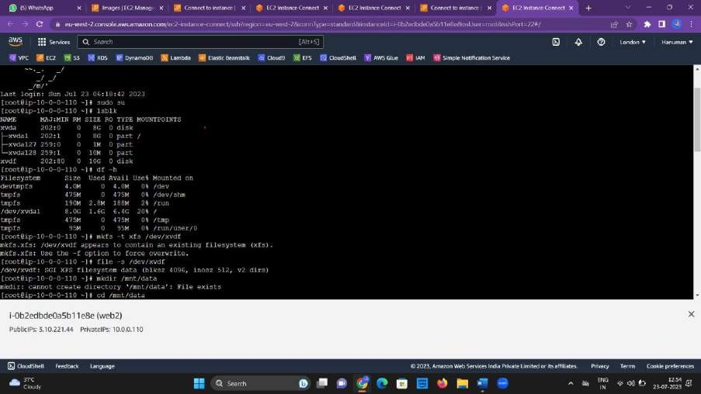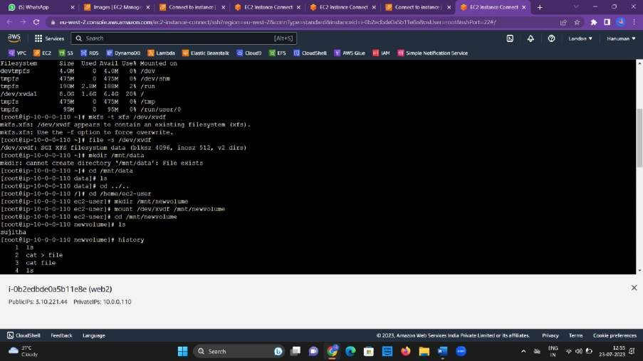

64

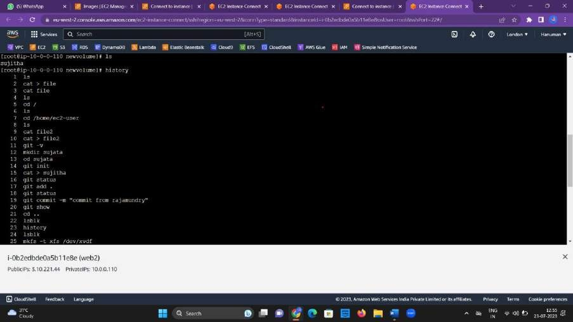

When entered ls command it displayed the data that is entered in the instance of other region. This indicates that data transfer is succesfull.

65

CONCLUSION:

This architecture is to transfer the data from an instance of one VPC with its

corresponding subnet to other instance of another VPC with its corresponding subnet via snapshot and its copy with extra volume. Also, the AMI (Amazon

Machine Images) in this helps you to create the virtual servers known as EC2 instances in the Amazon Web Services (AWS) environment. The cloud 9 associated with the first VPC helps you to store the files locally on the instance or servers. The IAM (Identity and Access Management) in our architecture is an identity that we

can create in our account that has specific permissions. EFS in this architecture i.e. Elastic File Systems helps to create, mount the file system on an Amazon EC2 instance. The last tier -S3, Simple Storage Service is cloud object storage with

industry-leading scalability, data availability, security and performance.

66



67